Quilt As You Go Tutorial

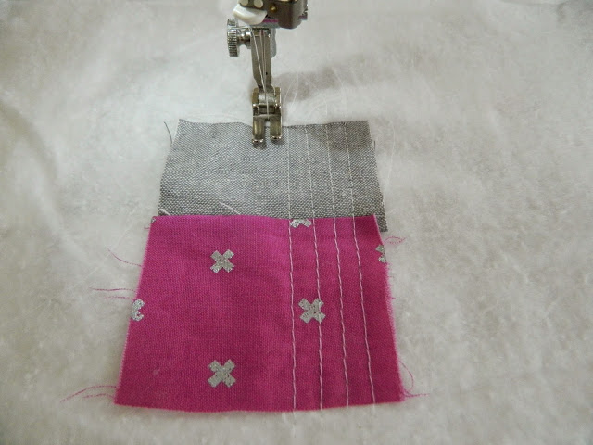

I usually start by stitching two smaller scraps together. Open the seam and place it right side up in the middle of your batting (just eyeball it, no precise measuring is needed). Hold your scraps steady so you have no puckers and quilt using straight lines as shown in the picture above.

Please note: use walking foot for your machine if you have one. If, however, you don't have one (or feel lazy like me to change your sewing machine feet) regular foot will work fine, just go slow and hold your fabric straight and smooth as you sew. You could also secure the piece you're quilting by using a few pins if preferred.

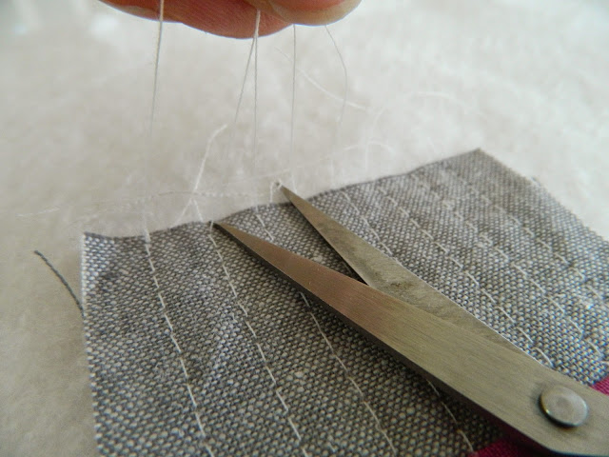

Trim all the thread ends after finishing your quilting on the first scrap piece. Make sure to trim threads after attaching every new scrap.

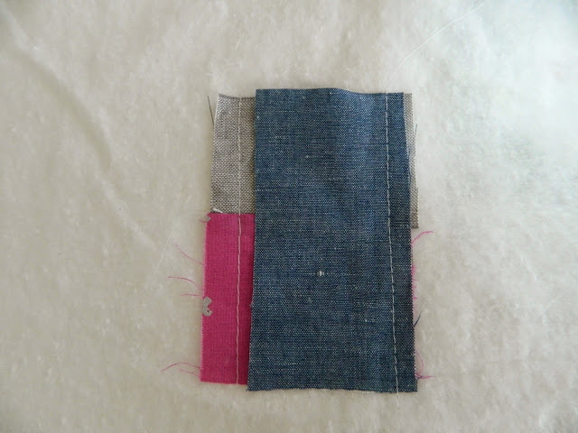

Place another scrap right side down on quilted patchwork (again, eyeball its size, it can be slightly bigger than what you need). Attach using 1/4" seam allowance.

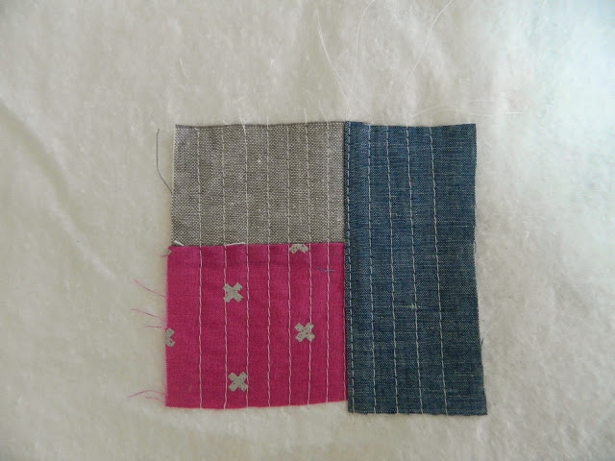

Smooth the seam with your fingers and flip the scrap over the seam (it's right side up now). Quilt it using straight lines again. Make sure to hold the piece you're working as straight as possible to prevent any shifting or, as mentioned before, use a few pins to secure it to batting.

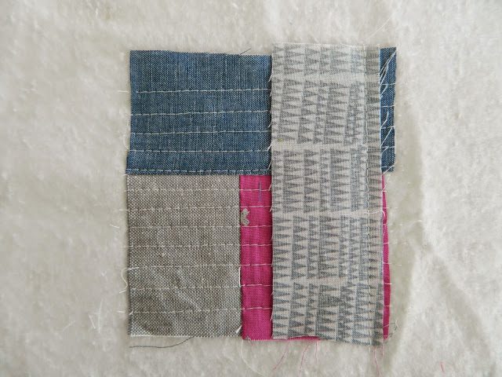

Turn the patchwork and place another scrap right side down. Attach using 1/4" seam allowance.

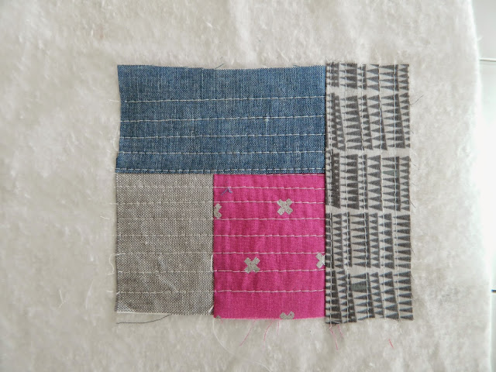

Again, smooth the seam with your fingers and flip the scrap right side up. Quilt it using straight lines.

Continue adding scraps all the way around your patchwork using this same technique.

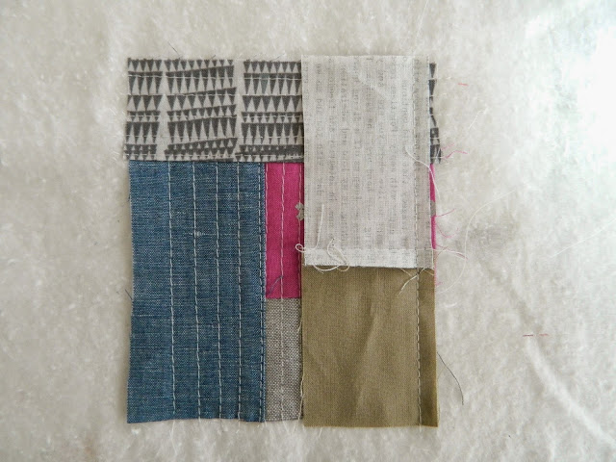

As the patchwork sides get longer, I usually stitch two or three different scraps into one longer piece and add it as one scrap to give the finished slab a more scrappy look. I also don't necessarily go all the way around the attached patchwork all the time. Sometimes I decide to add scraps to sides only and then continue going around. (see picture below)

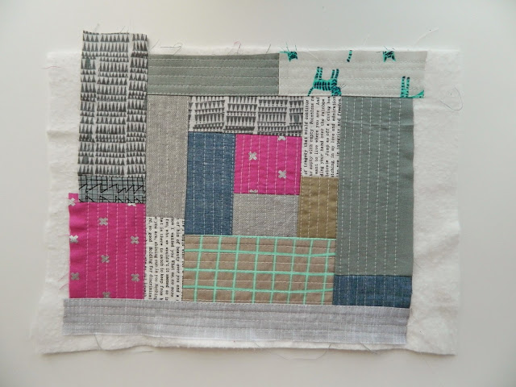

Keep adding scraps and quilting them until you have a big enough slab for your project. Use it as you would any piece of thicker fabric. You could turn them into baskets, pouches, bags, potholders, or even quilt blocks, possibilities are endless.

I turned this quilted slab into a large knitting pouch (finished size 8" tall x 11" wide).

