Personality Pillow

Week 1 - Intro Project

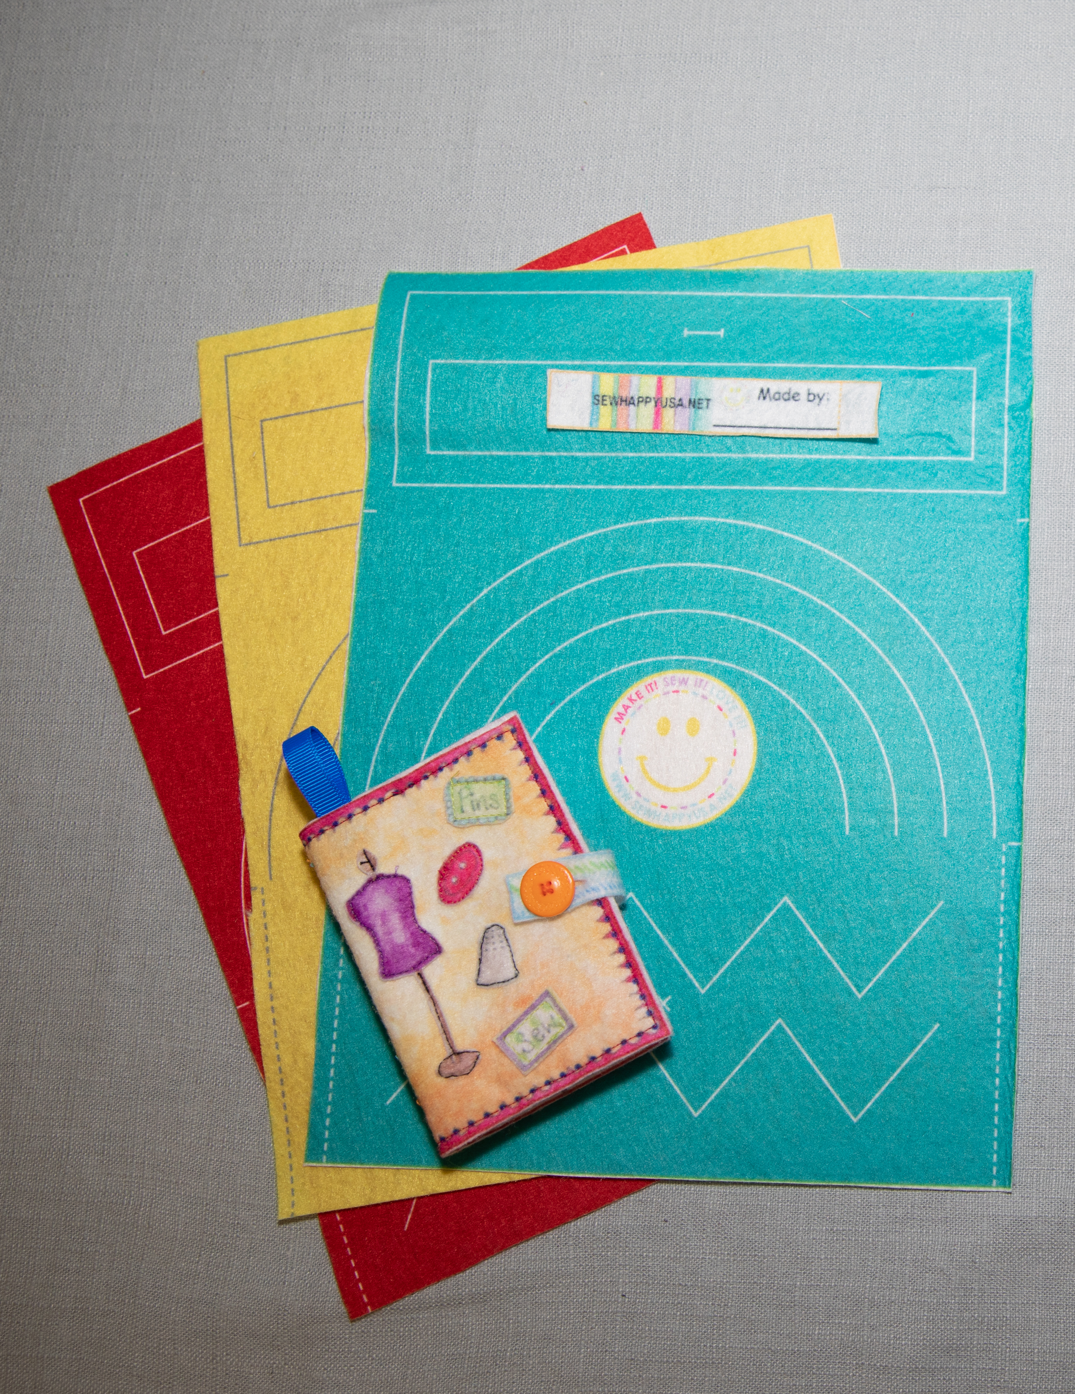

Note: If a student has already made the intro felt pouch they can either make a “Design Your Own” felt pouch using a plain piece of felt and felt scraps.

Additional Materials Required:

Introductory Felt Pouch Fabric
“Design Your Own” felt and felt scraps
Buttons
Hand Sewing Needles

Class

- Introduction (10 Minutes)
- Introduce yourself and tell the kids what to call you (eg Miss Heidi or Mrs. G…)
- Explain The “Sew Happy Way” and Safety Rules
- Give a brief overview of the classes ahead showing samples of projects. Explain GOALS for the complete session and GOALS FOR TODAY

- Basic Anatomy of Sewing Machine (10 Minutes)
- With machines in front of students discuss the following keywords:
    - On/Off Switch
    - Bobbin
    - Thread
    - Needle
    - Presser Foot
    - Hand or Fly Wheel
    - Presser Foot Lever
    - Foot Pedal

- Sew Felt Fabric (30 Minutes)
With speed on SLOWEST setting, stitch:
- Start with the STRAIGHT LINES on the boxes
- Pivots/Corners (Explain how to lift presser foot and swivel while the needle STAYS in the fabric)
- Curves (Demonstrate how to lift the presser foot making small turns as you sew around the curve).

- At this point you should have 30 minutes remaining and you need to start cleaning up 10 minutes before the end of the class.
- Fold the felt where the small markings are and pin the pouch at both sides.
- Stitch with 3 back stitches at beginning and end.
- If time hand sew the button and cut the buttonhole (otherwise this can be done in week 2)

Any student who has already made the felt pouch should be able to work through the “Design Your Own” felt pouch with only a little instructor guidance.

