Quilted Tote Bag Week 3
EZ Strips

Additional Materials Required:

5 x 9” Fabric Strips Per Student
8” x 8” Lining Fabric
18” Rulers
Fabric Markers or Frixion Markers
Sticky Backed Fabric Squares
Iron & Ironing Board

Class

- Set-up, Arrival, Welcome & Safety (see separate info)
- Refresher of “Basic Anatomy of Sewing Machine” (5 Minutes)
    - On/Off Switch
    - Bobbin
    - Thread
    - Needle
    - Presser Foot
    - Hand/Fly Wheel
    - Presser Foot Lever
    - Foot Pedal

- Begin The EZ Strips

- Demonstrate how to stitch the strips of fabric together.
  - Choose 2 strips and place them on table, side by side and right sides up

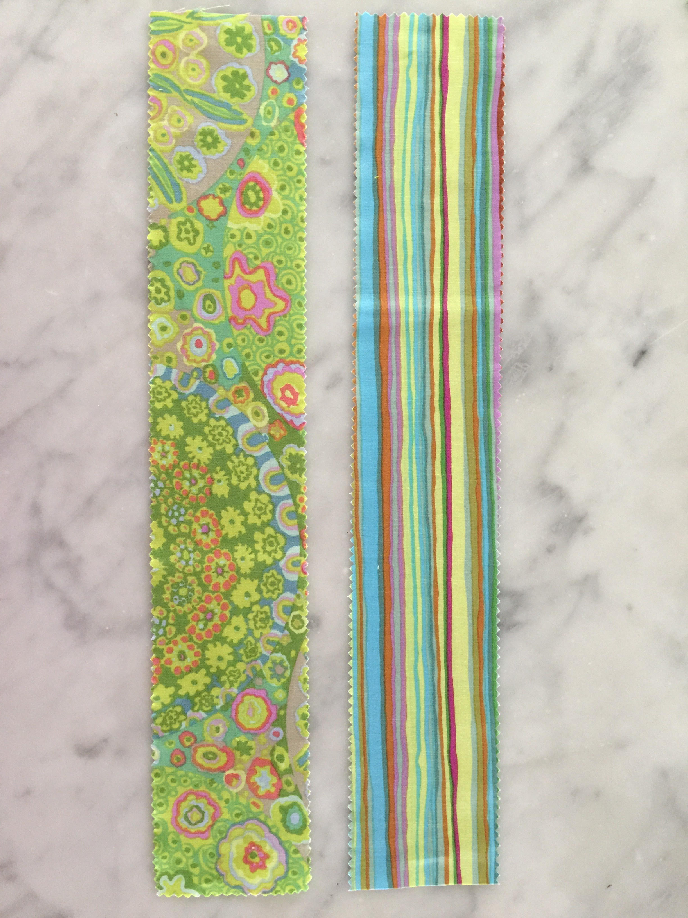

  - Lift one piece up and place it face down (right sides together) on other piece of fabric. The edges should match all the way down

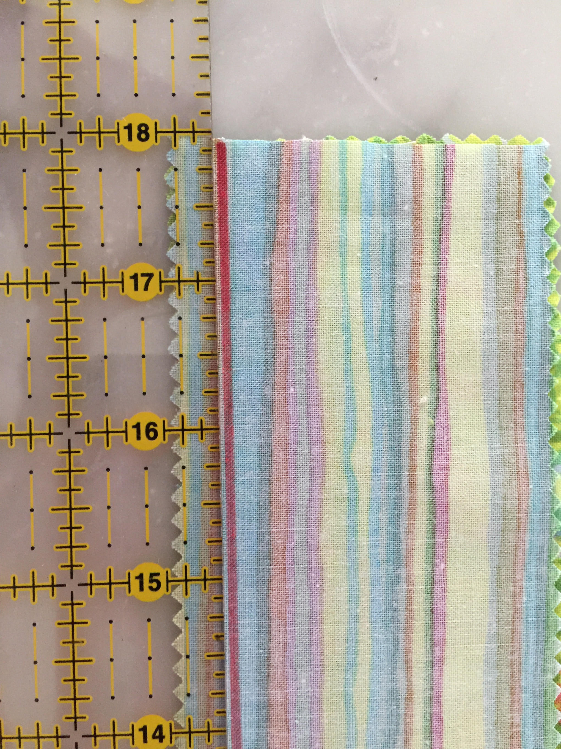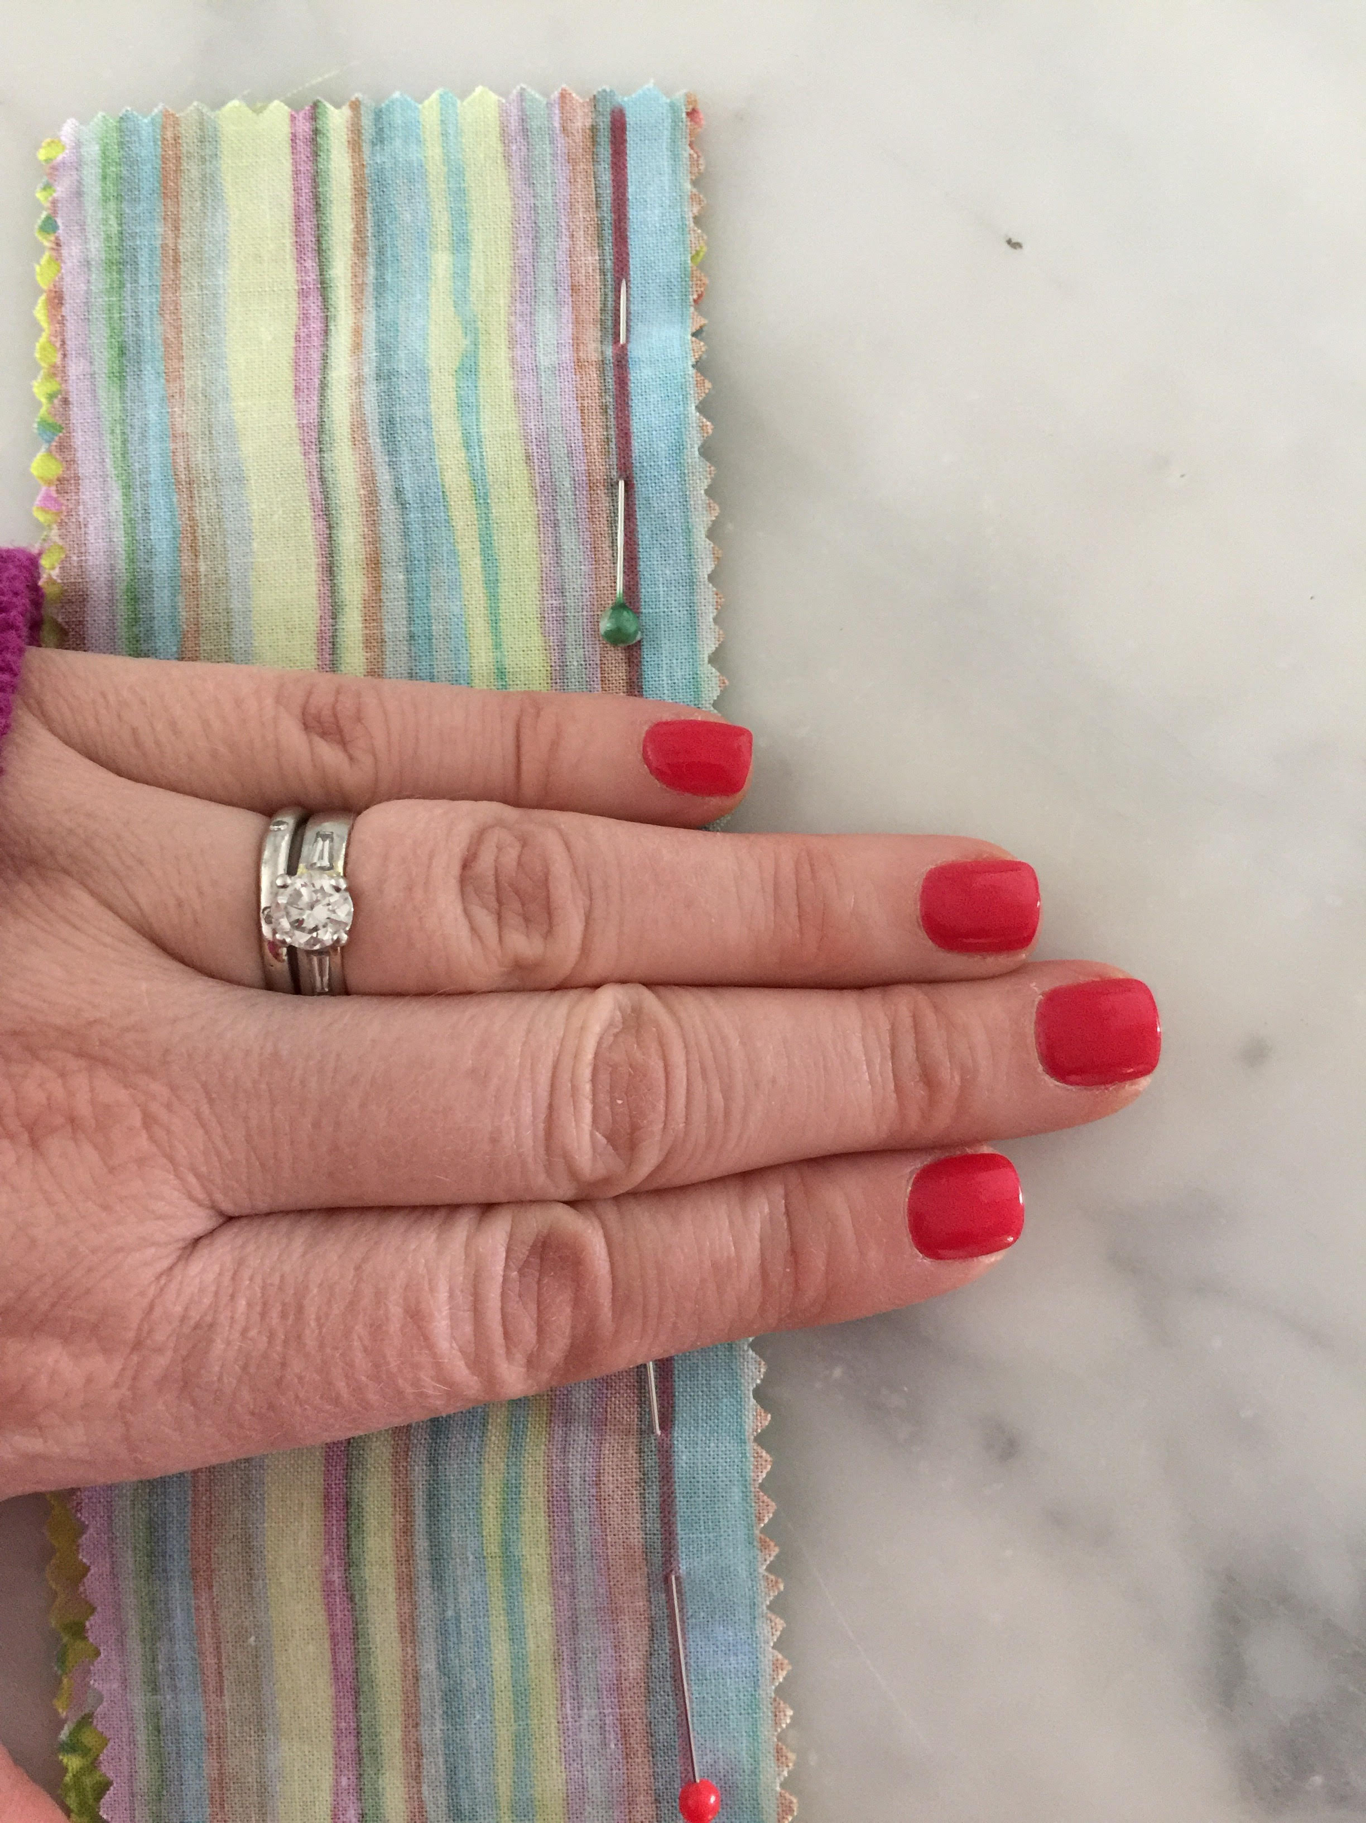

  - Draw a line 1/2” in from long edge of fabric all the way from top to bottom
  - Pin along the line leaving 4 fingers in between each pin. Make sure pins are pointing upwards
  - Insert fabric in to machine with needle inserted on the line almost at the top of the fabric
  - Stitch forward 3 stitches
  - Stitch backwards 3 stitches
  - Stitch all the way along the line until the needle reaches the end of the fabric
  - Stitch backwards 3 stitches
  - Stitch forwards 3 stitches
  - Raise the needle
  - Raise the presser foot
  - Pull the fabric out to the left and cut the thread on the cutter

  - Open out the fabric so both pieces are showing

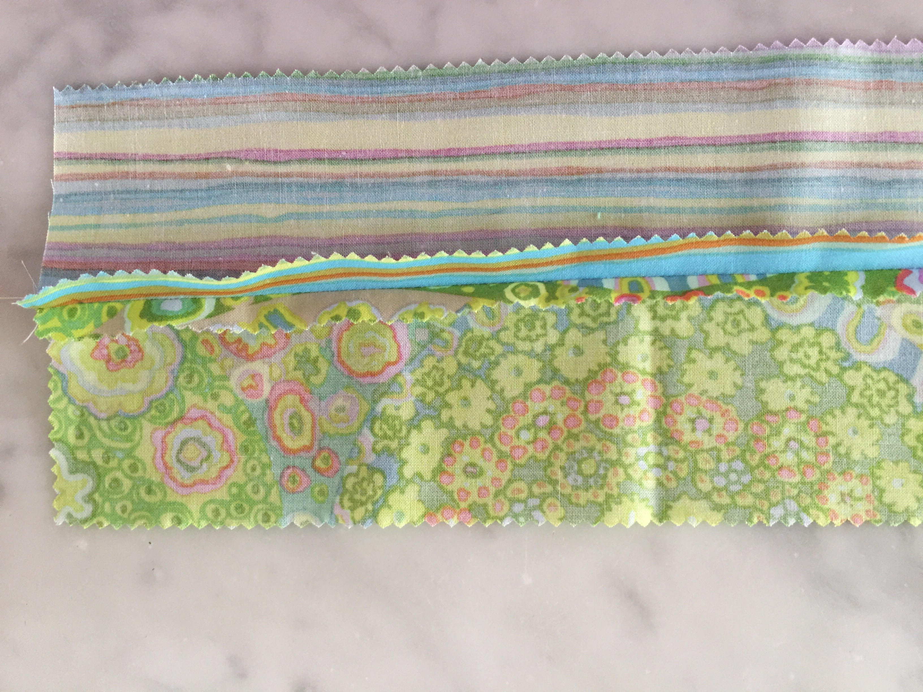

  - Finger press the seam open.
  - Iron

- Add another strip in exactly the same way

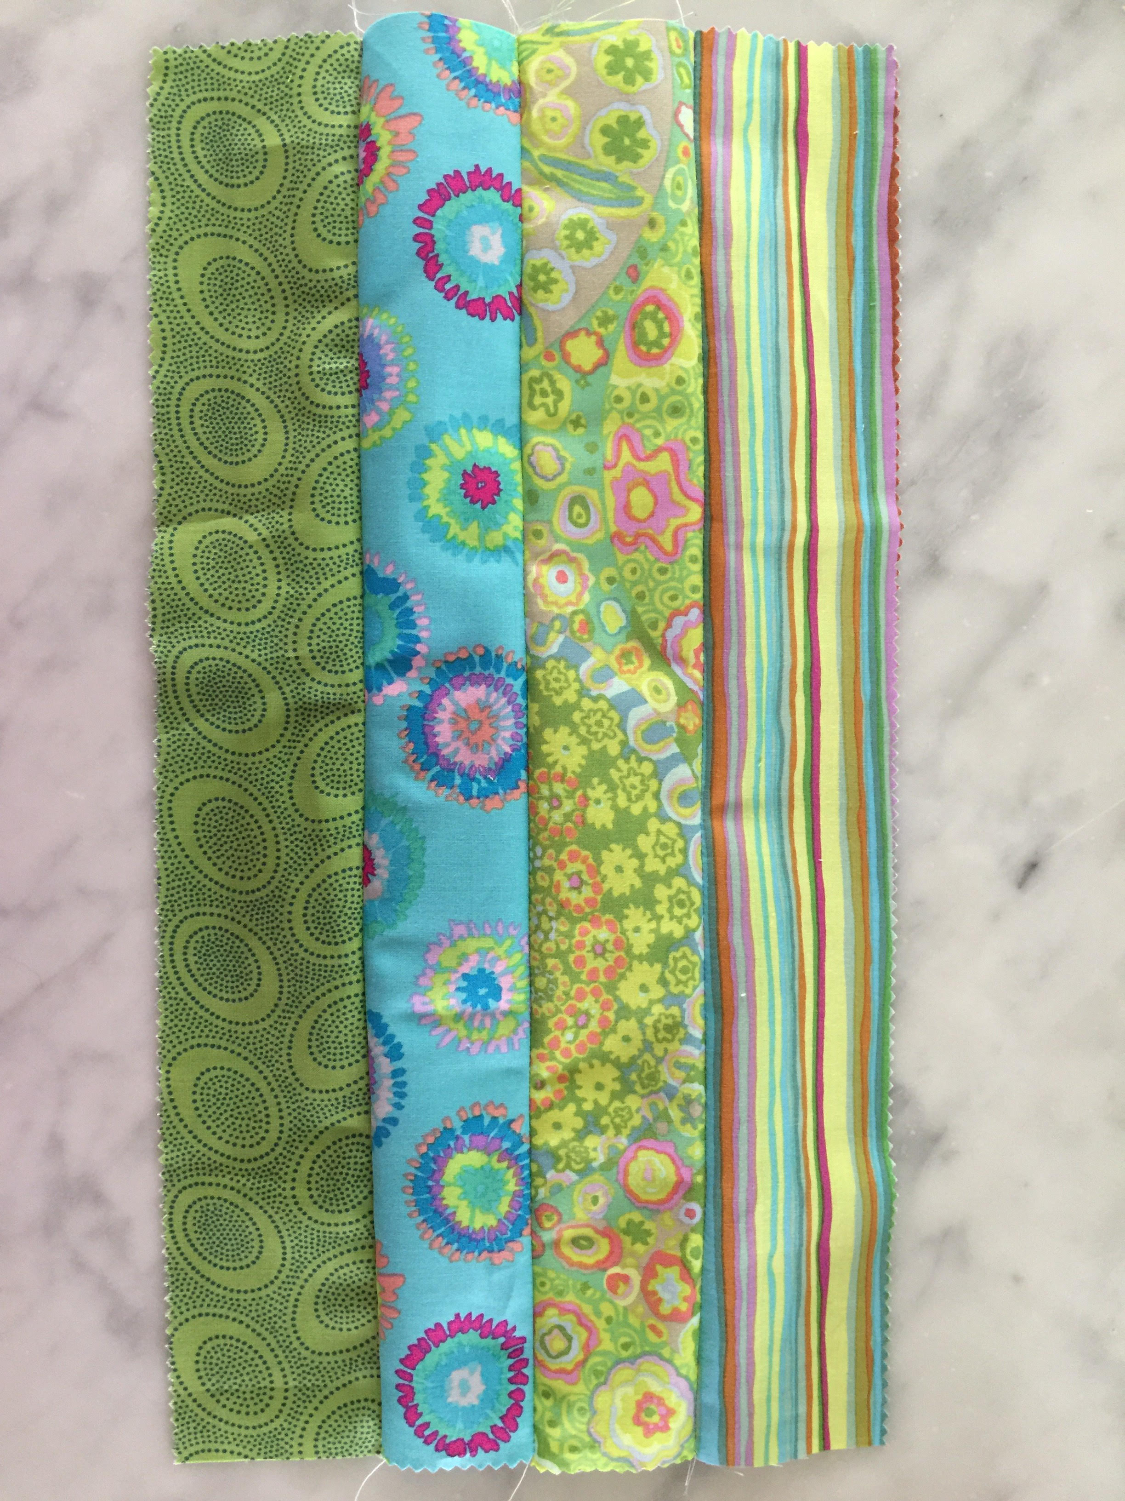

- Continue to add strips until strips have been used. Try to keep the strips in a random order and start and end with 2 different fabrics. This will create a better patchwork effect.

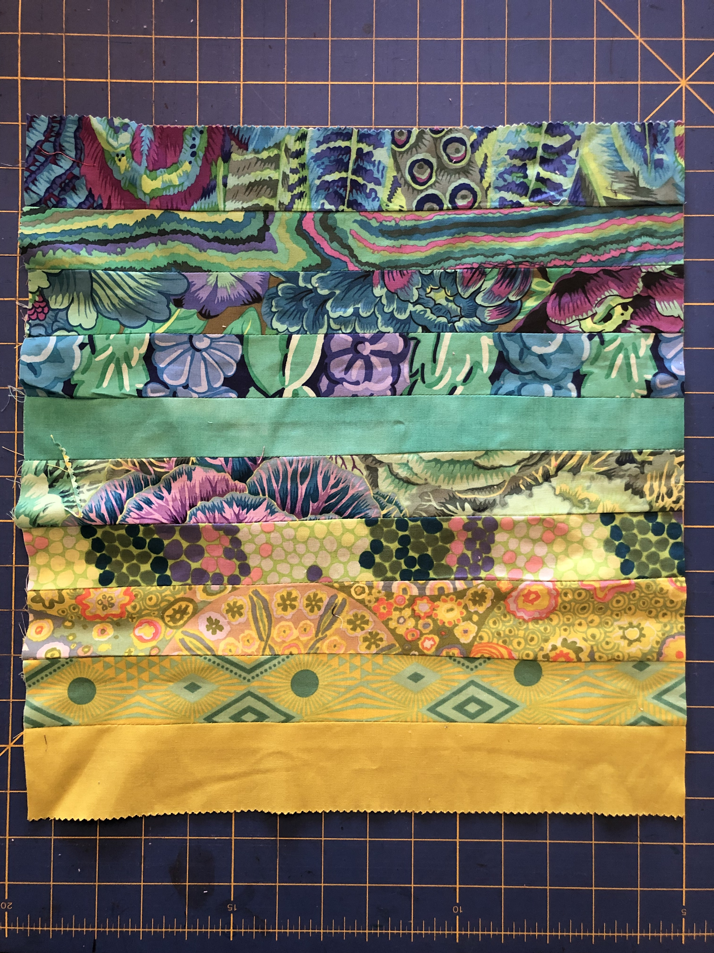

- With right sides together stitch EZ Strip fabric to lining fabric along TOP EDGE ONLY
- Flip to right side and press seam flat
- Put aside until later

