Beginner Sewing Machine & Hand Sewing Combo
Lesson 4

 | Today’s Sewing Machine Project | Pillow (may be a different design)  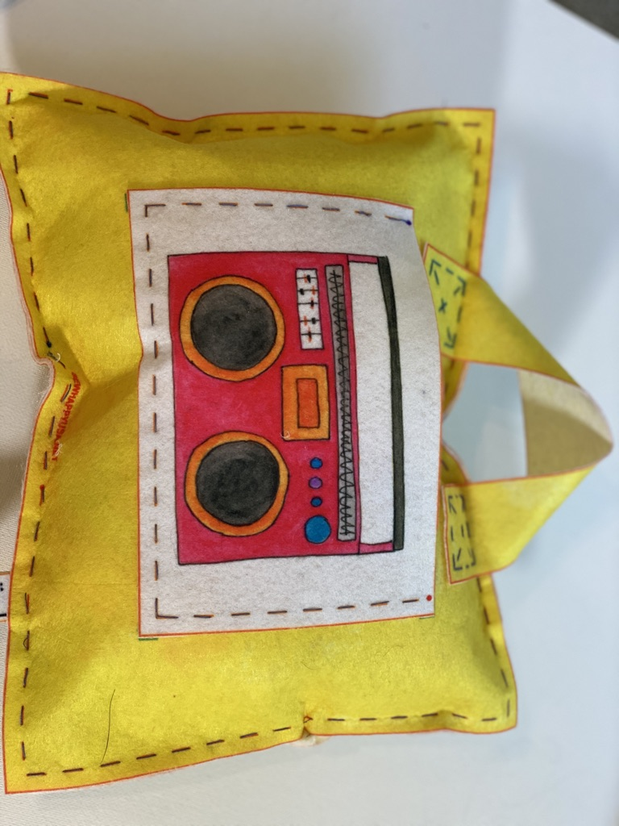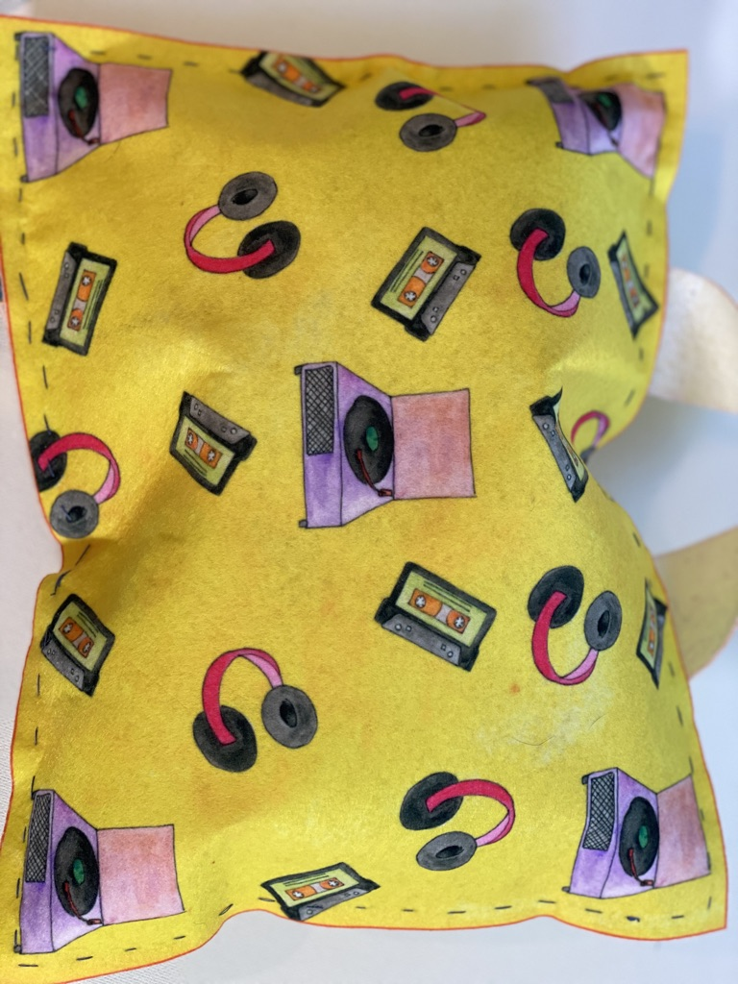
 | Today’s Hand Sewing Project | - Hand sew pillow opening closed  - Start keychain (if time allows)
 | Today’s New Skills | How to wind and insert bobbin
 | Extra Materials Needed | - Pillow Strap  - Stuffing
10 mins | Start of Class | - Sew Happy Way (See Instructor Binder)  - Goals For Today “To sew on the strap, to sew the pillow together, to stuff the pillow and hand sew the opening closed.”
5 Mins | Refresher | Basic Anatomy of Sewing Machine:  - On/Off Switch  - Bobbin  - Thread  - Needle  - Presser Foot  - Hand/Fly Wheel  - Presser Foot Level

15 Mins | Demonstrations/New Skills | Demonstrate winding and inserting a bobbin:  - Have the students follow along with you  - After the machine is threaded and the bobbin is inserted have the students sew a few stitches on a scrap piece of fabric.  - Explain how they should check that the machine is threaded correctly, do the stitches look neat and flat and is the machine resisting or making any strange noises? If this is the case help them to re-thread.
20 Mins | Machine Sewing | - Sew The Strap to the Pillow Front:  - Cut the strap  - Pin strap to pillow front (lining up with markings and matching the colors on pillow)  - Stitch in place making sure to do 3 back stitches at the beginning and end  - Sew The Pillow Front To Back:  - With wrong sides together pin the pillow front to pillow back  - Sew around stitch lines leaving opening between the red and blue dot  - Stuff pillow making sure to push small handfuls of stuffing in to corners of pillow  - Pin opening closed (ready to hand stitch closed)
30 Mins | Hand Sewing | Hand stitch pillow opening closed:  - Stitch along stitchlines making sure the opening is securely closed  - If time left over start to make keychain
10 Mins | End Of Class | Clean-up & Dismissal

