 | Monday
8am - 9am or  12pm - 1pm | BEFORE CAMP - EACH DAY  - Set the studio up following Covid guidelines (open windows, turn on fans, turn on air purifier, adjust AC  - Thread machines  - Make sure bobbins are full and that you have extra pre-wound bobbins  - Have all of the materials and supplies for the day ready  - Have coloring sheets and markers out  - Have large post-it ready for “Studio Rules”  - Unlock bathroom(s)
9am - 9.15am or  1.00pm - 1.15pm | WELCOME - EACH DAY  - Meet ‘n’ Greet - Campers enter studio and:  - Sanitize hands  - Put water and phones (and anything else) in designated area  - Welcome Meeting  - Monday -  - Share “My name is…and I learned to sew at/when…”  - Go around the room asking everyone to share where they learned to sew or if they have never sewn before what they are most looking forward to at camp.  - Tuesday - Friday - share a fun fact about you and go round the room asking everyone to share their fun fact (examples are favorite movie, name of pet, favorite hobby etc)  - Goals for the week -  ● To learn how to machine sew and hand sew  ● To make a felt pouch, a pair of pajama shorts, t-shirt, keychain, friendship bracelets and craft activities  ● To make new friends  ● To have a fun camp experience  Goals for today -  ● To learn how to use a sewing machine  ● To make a felt pouch  ● Select pajama fabric  ● Sketch designs for pajamas and t-shirt  - Classroom Rules - Use large post-it and Sharpie.  - Kids should come up with the rules and if they miss one out give them hints. This is a “living” document which can be added to during camp. It should be displayed on the wall during each camp so it can be referred back to if necessary.  - Each of the following topics should be covered:  - Safety (general studio safety (not sewing machine safety as this will come later)  - Be kind (specifically - be positive about other campers’ work)  - Be patient  - Be respectful of other people’s property  - Stay in seats unless asked to move around the studio  - No inappropriate language  - Don’t touch anything else in the studio unless instructed to  - Ask permission to go to bathroom, only one camper at a time  - No phones, water or snacks (water at designated water breaks unless they need more then they should ask)
9.15am - 9.35am or  1.15pm - 1.35pm | WELCOME ACTIVITY  Dice Activity 1 - “All About Me”  - Hand out Sheets “Dice Activity - All About M  - e”  - Campers should spend 15 minutes working on this  - Go around the room asking campers to tell everyone about themselves  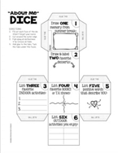 | Supplies Needed:  - Dice Activity “All About Me” Sheets  - Markers/Pens/ Pencils
9.35am - 10.30am or  1.35pm - 2.30pm | ACTIVITY 1  - Basic Anatomy of Sewing Machine (10 Minutes)  - With machines in front of students discuss the following keywords:  - On/Off Switch  - Bobbin  - Thread  - Needle  - Presser Foot  - Balance Wheel  - Presser Foot Lever  - Foot Pedal  - Safety (2-3 Minutes)  - Discuss safety hazards  - Electrical Cords - be careful not to trip  - Sharp pins & needles on floor - keep shoes on  - Keep long hair away from machine  - Driver’s Test (If a camper has already done this activity at a previous camp we have other intro projects - ask Kim)  With speed on SLOW, start to stitch:  - Start with STRAIGHT stitch on the straight lines  - Pivots/Corners (Explain how to lift presser foot and swivel while the needle STAYS in the felt)  - Curves (Demonstrate how to lift the presser foot making small turns as you sew around the curve)  - Driver’s Test (Campers stitch along the crazy lines trying to be as accurate as possible)  - Trim excess fabric from edges of fabric | 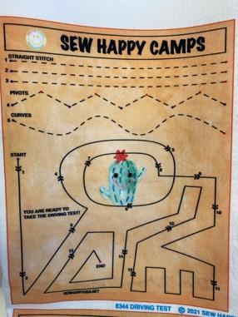
BREAK | 15 MINS - Campers should have water and use the bathroom at this time. Play a game!
10.45am - 11.45am or  2.45pm - 3.45pm | ACTIVITY 2  - Camper’s select fabric for PJ shorts  Pajama and T-Shirt Design  - Hand out a fashion sheet to each camper  - Talk about options for pajamas t-shirt designs  ● Which fabrics are available  ● Pockets/applique  ● Matching the t-shirt to pj pants  Campers use markers/pencils to sketch their design. They can use fabrics in free sew bin to add to their sketch | Supplies Needed:  - PJ Fabric  - Poster board  - Glue sticks  - Fabric scraps  - Pens, etc
11.45am - 12pm or  3.45pm - 4pm | CLEAN UP / SHOW & TELL  - Campers - put all of their materials in their ziploc bag  - Hand each camper a wipe and ask them to wipe their work station including the hand wheel on the sewing machine and the desktop.  - Show & Tell (Instructor does on Monday then campers the rest of the week. Remind them!)  - Ask campers to share “What I liked about camp today”  - If there is still time ask a “Would You Rather” question or two. (In binder)
12pm or  4pm | DISMISSAL  - Have campers collect their belongings (water bottle, phone etc)  - Have campers line up  - Instructor should lead the group down to the pick-up location in a quiet and orderly manner  - Follow dismissal procedure  Return to studio, sanitize and clean so it’s ready for next class.

 | TUESDAY | Notes
8.30am - 9am or  12.30pm - 1pm | BEFORE CAMP STARTS  IMPORTANT: Follow Instructions from Monday
9am - 9.15am or  1pm - 1.15pm | WELCOME MEETING - IMPORTANT: Follow instructions from Monday  Goals for today:  - To start making the PJ shorts  - To start working on the t-shirt design
9.15am - 9.35am or  1.15pm - 1.35pm | WELCOME ACTIVITY  Dice - Activity 2  - Campers get out Sheets, Dice Activity - “About Me”  - Cut around the outer edge. Fold along the lines to make a 3D dice. Use glue to hold in place. | Supplies Needed:  - Dice Sheets  - Markers  - Glue Sticks
9.35am - 10.30am or  1.35pm - 2.30pm | ACTIVITY 1  PJ Shorts (Split bigger groups and follow “1/2 class” instructions”  - Campers should measure their waists and hips to figure out which size pattern they need  - With the 2 pieces of fabric together and facing the right direction, place pattern on fabric (straight - in most cases the instructor can eyeball to place the pattern correctly)  - Pin pattern in place leaving 3 or 4 fingers between each pin and pinning close to edges  - Draw around pattern with a frixion marker being careful to mark notches  - Remove pattern  - Carefully cut fabric, including notches | Supplies Needed:  - Fabric  - Patterns  Frixion Markers  - Pins  - Tape Measures  - Scissors
BREAK | 15 MINS - Campers should have water and use the bathroom at this time. Play a game!
10.45am - 11.45am or  2.45pm - 3.45pm | ACTIVITY 2:  T-Shirt Design  - Hand out a fashion sheet to each camper  - Talk about options for t-shirt designs  ● Which fabrics are available  ● Pockets/applique  ● Matching the pj pants  Campers use markers/pencils to sketch their design. They can use fabrics in free sew bin to add to their sketch  Don’t start sewing the t-shirt - only designing at this session. If campers finish early they can Free Sew - following Free Sew Guidelines | Supplies Needed  - Fashion Sheet (with 2 or 3 models)
11.45am - 12pm or  3.45pm - 4pm | CLEAN-UP / SHOW & TELL  Follow instructions from Monday
12pm or  4pm | DISMISSAL  Follow instructions from Monday

 | WEDNESDAY | Notes
8.30am - 9am or  12.30pm - 1pm | BEFORE CAMP STARTS  IMPORTANT: Follow Instructions from Monday
9am - 9.15am or  1pm - 1.15pm | WELCOME MEETING - IMPORTANT: Follow instructions from Monday  Goals for today:  - To continue sewing the PJ shorts  - To hand sew a keychain or bookmark
9.15am - 9.35am or  1.15pm - 1.35pm | WELCOME ACTIVITY  Wordsearch - Denim Theme (Solution in binder)  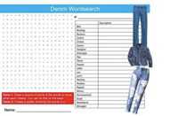 | Supplies Needed:  - Wordsearch Sheets “Denim”
9.35am - 10.30am or  1.35pm - 2.30pm | ACTIVITY 1  PJ Shorts (Split bigger groups and follow “1/2 class” instructions”  - Pin and stitch inner legs together, with a ½” seam allowance  (Draw a stitch line with a frixion marker for campers)  - Trim seam allowance down to ¼” and zigzag the raw edges  - Turn just one leg section right side out.  Insert the turned leg inside the other so that the right sides are together and the inner leg seams are matching.  - Match the raw edges and notches of the crotch seam.  ● Pin (making sure campers take extra care stitching around the curve - draw stitch line ½”from raw edge with a frixion marker).  ● Stitch crotch along entire seam  ● Stitch again close to the first stitch line to reinforce  - Trim the seam allowance along the curved edge down to about ¼” from the stitch line (instructors can do this for beginners)  - Experienced campers zigzag the raw edges together  - Turn PJ’s right side out  Start the Waistband:  - Fold over a ½” seam and a 1” seam, pin in place  - Draw a stitch line for campers with a 2” - 3” opening  - Demonstrate Free Arm Sewing - Show how to remove the “Flat Bed Attachment with Accessory Compartment” from the sewing machine  and how to use the free arm when sewing.  - Continue PJ shorts tomorrow… | Supplies Needed:  - PJ Fabric  - Frixion Markers  - Pins
BREAK | 15 MINS - Campers should have water and use the bathroom at this time. Play a game!
10.45am - 11.45am or  2.45pm - 3.45pm | ACTIVITY 2:  Hand Sew The Keychain - Teach basics of hand sewing  - Demonstrate threading a needle and tying a knot (follow Sew Happy guidelines on Instructor Page on website)  - Campers practice threading a needle and tying a knot  - Demonstrate how to cut fabric  - Campers cut out the keychain and slide keyring over one side of keychain so it’s in the middle  - Demonstrate whipstitch  - Campers start stitching around keychain using the dots as a guide  - Demonstrate the lock stitch  - As campers thread gets as short as 4” they do a lock stitch, cut their thread and start the entire process again (thread a needle and tie a knot)  - Complete the keychain | Supplies Needed:  ● Pincushions  ● Needle Threaders  - Laminated rulers
11.45am - 12pm or  3.45pm - 4pm | CLEAN-UP / SHOW & TELL  Follow instructions from Monday
12pm or  4pm | DISMISSAL  Follow instructions from Monday

 | THURSDAY | Notes
8.30am - 9am or  12.30pm - 1pm | BEFORE CAMP STARTS  IMPORTANT: Follow Instructions from Monday
9am - 9.15am or  1pm - 1.15pm | WELCOME MEETING - IMPORTANT: Follow instructions from Monday  Goals for today:  - To complete the PJ shorts  - To make a craft activity
9.15am - 9.35am or  1.15pm - 1.35pm | WELCOME ACTIVITY  Stickers  - Campers color and cut out stickers  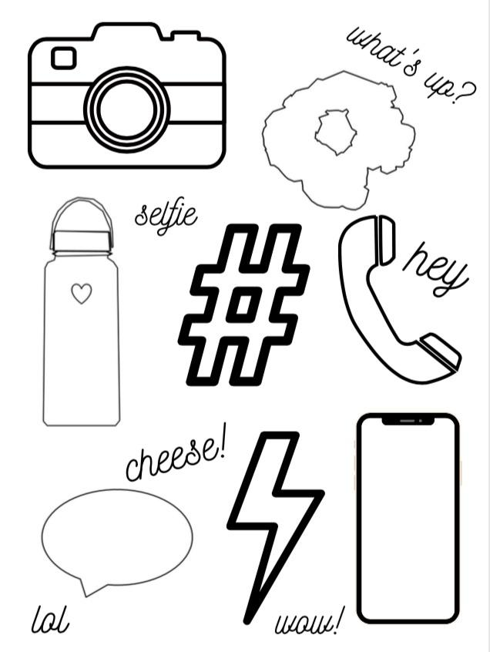 | Supplies Needed:  - Sticker Sheets  - Markers
9.35am - 10.30am or  1.35pm - 2.30pm | ACTIVITY 1  PJ Shorts (Split bigger groups and follow “1/2 class” instructions”  - Insert elastic - measure camper’s waist and cut a piece of elastic 2” longer  - Using a bodkin pull elastic through waistband casing - use a safety pin to secure the end of the elastic to the shorts (to prevent it being pulled too far)  - Overlap the elastic and make sure it isn’t twisted inside the waistband  - Camper should try on the shorts and adjust the elastic if necessary  - Securely stitch the elastic together  - Stitch the opening closed  - Stitch “in the ditch” at the side seams to hold the elastic in place  - Add a ribbon at the front of the shorts. Tie it in a bow.  - To hem the PJ shorts - turn under a 1/2”.  - Pin and stitch with a zigzag stitch close to folded edge.  (Campers have time to complete the shorts tomorrow) | Supplies Needed:  - Elastic (¾”)  - Bodkins  - Safety Pins  - Frixion Markers  - Pins
BREAK | 15 MINS - Campers should have water and use the bathroom at this time. Play a game!
10.45am - 11.45am or  2.45pm - 3.45pm | ACTIVITY 2:  Craft Activity  - See separate tutorial
11.45am - 12pm or  3.45pm - 4pm | CLEAN-UP / SHOW & TELL  Follow instructions from Monday
12pm or  4pm | DISMISSAL  Follow instructions from Monday

 | FRIDAY | Notes
8.30am - 9am or  12.30pm - 1pm | BEFORE CAMP STARTS  IMPORTANT: Follow Instructions from Monday
9am - 9.15am or  1pm - 1.15pm | WELCOME MEETING - IMPORTANT: Follow instructions from Monday  Goals for today:  - To complete all projects  - To make friendship bracelets  - Fashion Show (use mannequins to show outfits, each camper presents their creations)
9.15am - 9.35am or  1.15pm - 1.35pm | WELCOME ACTIVITY  Friendship Bracelets  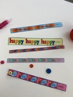  ● Campers cut out the bracelets  ● To cut the bracelet to size - measure around camper’s wrist and cut (allowing for a 1” overlap)  ● DO NOT CUT THE BUTTONHOLE END  ● Cut the buttonhole (CAREFULLY!)  ● Mark the placement of the button  ● Stitch a button in place  ● Make more if time! | Supplies Needed:  - Friendship Bracelets  - Buttons
9.35am - 10.30am or  1.35pm - 2.30pm | ACTIVITY 1  Complete all projects:  PJ Shorts  T-Shirt  Keychain  Friendship Bracelets  Dice  Stickers
BREAK | 15 MINS - Campers should have water and use the bathroom at this time. Play a game!
10.45am - 11.45am or  2.45pm - 3.45pm | ACTIVITY 2:  Fashion Show  - Campers put their PJ’s and t-shirts on the mannequins  - Take turns presenting their mood boards and creations  - Instructor takes photos of campers and mannequins using photo booth props and “Selfie Wall”. (If Kim is present she will take photos) | Supplies Needed:  - Mannequins  - Selfie Wall (Silver Curtain)
11.45am - 12pm or  3.45pm - 4pm | CLEAN-UP / SHOW & TELL  Follow instructions from Monday.  Show campers samples of other camps. | CAMP SAMPLES
12pm or  4pm | DISMISSAL  Follow instructions from Monday

