 | Monday | Notes
Before Camp Starts | BEFORE CAMP - EACH DAY  - Set the studio up following Covid guidelines (open windows, turn on fans, turn on air purifier, adjust AC  - Thread machines  - Make sure bobbins are full and that you have extra pre-wound bobbins  - Have all of the materials and supplies for the day ready  - Have welcome activity and markers out on campers’ desks  - Have large post-it ready for “Studio Rules”  - Unlock bathroom(s)
9am - 9.15am or  1.00pm - 1.15pm  WELCOME ACTIVITY | 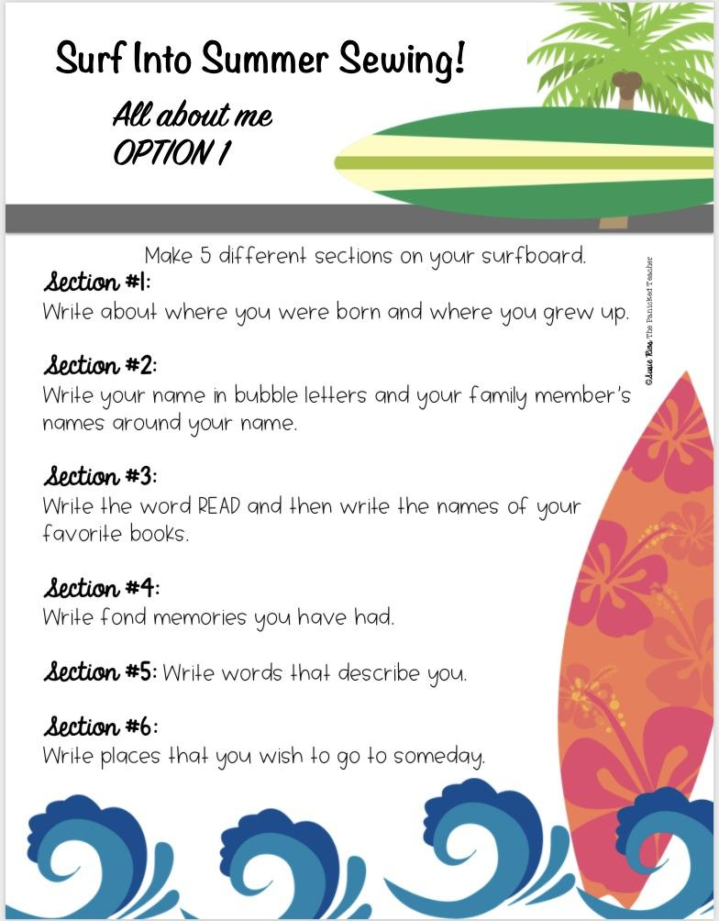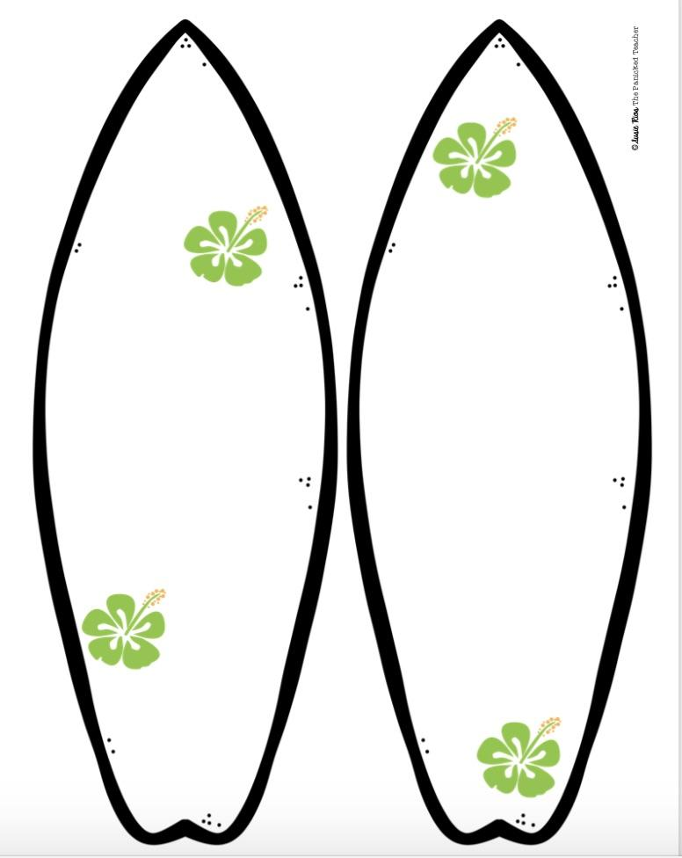
9.15am - 9.30am or  1.15pm - 1.30pm  Welcome Meeting | WELCOME - EACH DAY  - Meet ‘n’ Greet - Campers enter studio and:  - Sanitize hands  - Put water and phones (and anything else) in designated area  - Welcome Meeting  - Monday -  - Share “My name is…and I learned to sew at/when…”  - Go around the room asking everyone to share where they learned to sew or if they have never sewn before what they are most looking forward to at camp.  - Tuesday - Friday - share a fun fact about you and go round the room asking everyone to share their fun fact (examples are favorite movie, name of pet, favorite hobby etc)  - Goals for the week -  ● To learn how to machine sew and hand sew  ● To make a fun, appliqued beach bag and other arts and crafts activities  ● To make new friends  ● To have a fun camp experience  Goals for today -  ● To learn how to use a sewing machine  ● To take a “driver’s test”  ● To make a design for the beach bag applique  - Classroom Rules - Use large post-it/ paper sheet and Sharpie.  - Kids should come up with the rules and if they miss one out give them hints. This is a “living” document which can be added to during camp. It should be displayed on the wall during each camp so it can be referred back to if necessary.  - Each of the following topics should be covered:  - Safety (general studio safety (not sewing machine safety as this will come later)  - Be kind (specifically - be positive about other campers’ work)  - Be patient  - Be respectful of other people’s property  - Stay in seats unless asked to move around the studio  - No inappropriate language  - Don’t touch anything else in the studio unless instructed to  - Ask permission to go to bathroom, only one camper at a time  - No phones, water or snacks (water at designated water breaks unless they need more then they should ask)
9.30am - 10.30am or  1.30pm - 2.30pm  Activity 1 | Introduction To Machine Sewing  - Basic Anatomy of Sewing Machine (10 Minutes)  - With machines in front of students discuss the following keywords:  - On/Off Switch  - Bobbin  - Thread  - Needle  - Presser Foot  - Balance Wheel  - Presser Foot Lever  - Foot Pedal  - Safety (2-3 Minutes - use “Mr. Octopus”)  - Discuss safety hazards  - Electrical Cords - be careful not to trip  - Sharp pins & needles on floor - keep shoes on  - Keep long hair away from machine  - Start Driver’s Test  With speed on SLOW, start to stitch:  - Start with STRAIGHT stitch on the straight lines  - Pivots/Corners (Explain how to lift presser foot and swivel while the needle STAYS in the felt)  - Curves (Demonstrate how to lift the presser foot making small turns as you sew around the curve).  - Follow the lines for the Driver’s Test | 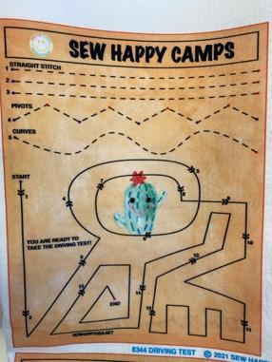
BREAK
15 MINS
10.45am - 11.45am or  2.45pm - 3.45pm  Activity 2 | Applique Design  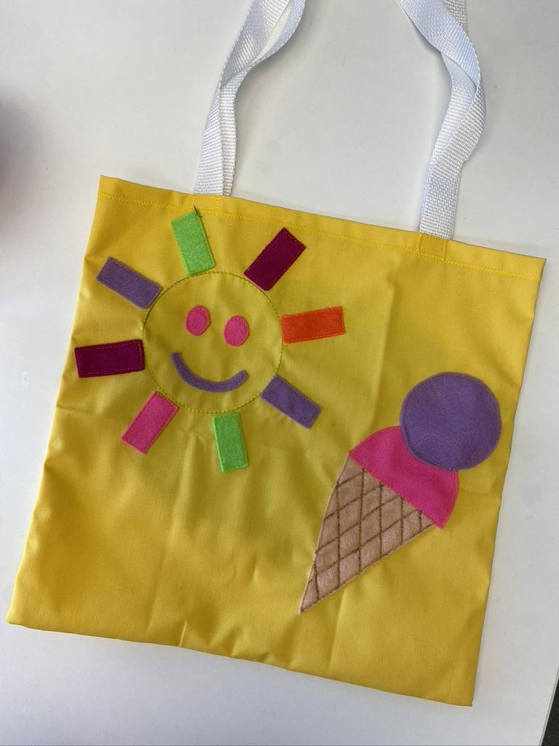  - Hand out a blank sheet of paper and a pencil to each camper  - Campers choose a bag color  - Show campers the Beach Bag sample and discuss ideas for their own designs.  - Campers should draw a simple design, either the sun or the ice cream or you can let them do their own design.  - Campers draw their design and then cut their designs from felt fabric (no other fabric)  NO SEWING DURING THIS ACTIVITY.
11.45am - 12pm or  3.45pm - 4pm | CLEAN UP / SHOW & TELL  - Campers - put all of their materials in their ziploc bag  - Show & Tell (Instructor does on Monday then campers the rest of the week. Remind them!)  - Ask campers to share “What I liked about camp today”  - If there is still time ask a “Would You Rather” question or two. (In binder)
12pm or  4pm | DISMISSAL  - Have campers collect their belongings (water bottle, phone etc)  - Have campers line up  - Instructor should lead the group down to the pick-up location in a quiet and orderly manner  - Follow dismissal procedure  Return to studio, sanitize and clean so it’s ready for next class.

 | Tuesday | Notes
Before Camp Starts | - See Monday studio set-up
9am - 9.15am or  1pm - 1.15pm  Welcome Activity | Surfboard Activity 2  - Hand out “Surf Into Summer Option 2” Sheets  - Campers should answer the questions by drawing or writing on the surfboards using different colors and pictures  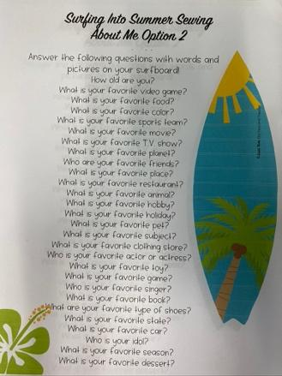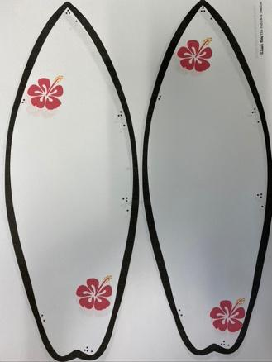 | Supplies Needed:  - Surf Into Summer Option 2 Sheets  - Markers
9.15am - 9.30am or  1.15pm - 1.30pm  Welcome Meeting | - Welcome Meeting (See Monday)  - Goals for today -  - To make the applique for the beach bag  - Safety (General)
9.30am - 10.30am or  1.30pm - 2.30pm  Activity 1 | Stitch Applique Design  - Pin one piece of felt on to the bag back and stitch in place before moving on to the next piece.
BREAK
15 MINS
10.45am - 11.45am or  2.45pm - 3.45pm  Activity 2 | Continue with applique  If a camper thinks they are finished encourage them to embellish with more applique, fabric markers or hand sewing.
11.45am - 12pm or  3.45pm - 4pm | Clean Up / Show & Tell - see Monday
12pm or  4pm | Dismissal - see Monday

 | Wednesday | Notes
Before Camp Starts | See Monday
9am - 9.15am or  1pm - 1.15pm | Wordsearch (Surf theme)  - Hand out Wordsearch Sheets  - Campers complete | Supplies Needed:  - Wordsearch Sheet  - Markers
9.15am - 9.30am or  1.15pm - 1.30pm | Welcome Meeting  - See Monday  - Goals for today -  - To embellish the back of the beach tote  - Safety (General)
9.35am - 10.30am or  1.35pm - 2.30pm  Activity 1 | - Embellish back of bag with text bubble - use BASIC decorative stitches to go around the outside of the text bubble  - Add applique or fabric marker designs  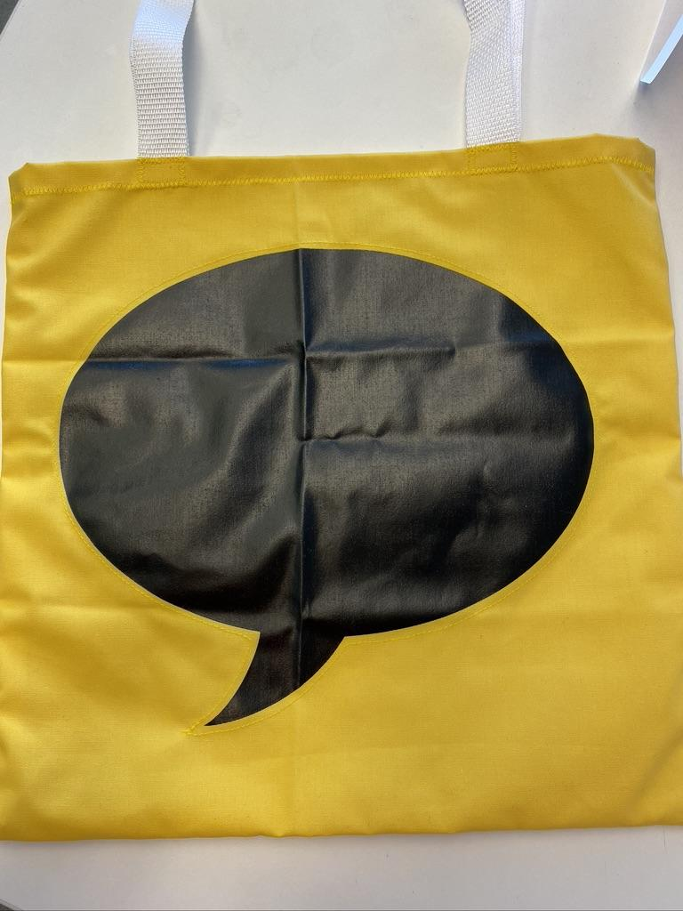
BREAK
15 MINS
10.45am - 11.45am or  2.45pm - 3.45pm  Activity 2 | Sew Bag Front To Bag Back  - With RST Pin & stitch bag sides and bottom  - Turn a ½” hem around top edge  - Pin & stitch. Use a zigzag stitch
11.45am - 12pm or  3.45pm - 4pm | Clean Up / Show & Tell - see Monday
12pm or  4pm | Dismissal - see Monday

 | Thursday | Notes
Before Camp Starts | See Monday
9am - 9.15am or  1pm - 1.15pm | Welcome Activity - Coloring Sheet (Surf Theme)
9.15am - 9.35am or  1.15pm - 1.35pm  Welcome Meeting | See Monday  - Goals for today -  - To finish the Beach Bag and stitch the straps in place  - To hand sew a keychain or bookmark  - Safety (General)
9.35am - 10.30am or  1.35pm - 2.30pm  Activity 1 | Stitch handles to bag  - Measure webbing and cut 2 pieces the same size (it may already be cut)  - Pin in place on the outside of the bag  - Stitch securely | - Webbing Straps
BREAK
15 MINS
10.45am - 11.45am or  2.45pm - 3.45pm  Activity 2 | Wave keychain  - Cut keychain, be careful not to cut through the adjoining strip  - Roll fabric to push through keyring  - Match front to back of keychain  - Pin and stitch around the edges using a whipstitch  OR Bookmark  (For campers who have done both at previous camps ask Kim)
11.45am - 12pm or  3.45pm - 4pml | Clean Up / Show & Tell - see Monday
4pm | Dismissal - see Monday

 | Friday | Notes
Before Camp Starts | See Monday
9am - 9.15am or  1pm - 1.15pm | Welcome Activity - Coloring Sheets
9.15am - 9.30am or  1.15pm - 1.30pm  Welcome Meeting | See Monday  - Goals for today -  - To complete all of the projects  - To make a surfboard necklace  - Safety (General)
9.30am - 10.30am or  1.30pm - 2.30pm  Activity 1 | Complete all projects:  - Beach Tote Bag  - Keychain or Bookmark  - Surfboard Necklace
 | Surfboard Necklace  Hand out materials  Campers:  - Use sharpies to color the wooden surfboard  - Thread the surfboard on to the string and tie a knot (leave it big enough to fit over camper’s head! | Supplies Needed:  - Surfboard Necklace Bag  - Sharpies
BREAK
15 MINS
10.45am - 11.45am or  2.45pm - 3.45pm  Activity 2 | If all projects are complete:  POCKET POUCH Or FREE SEW (make sure to follow Free Sew guidelines) - discuss with Kim
11.45am - 12.45pm or  3.45pm - 4pm  Clean Up / Show & Tell | - Campers should have all their projects ready to take home  - Final show and tell  - Ask campers to share “What I liked about camp this week ”  - If there is still time ask a “Would You Rather” question or two.
12pm or  4pm  Dismissal | - Have campers collect their belongings (water bottle, phone etc)  - Have campers line up  - Instructor should lead the group down to the pick-up location in a quiet and orderly manner  - Follow dismissal procedure  - Return to studio, sanitize and clean so it’s ready for next class  - Put away any excess materials from students’ ziploc bags, remove name labels and put in office for recycling - thank you.

