HEDGEHOG HOUSE

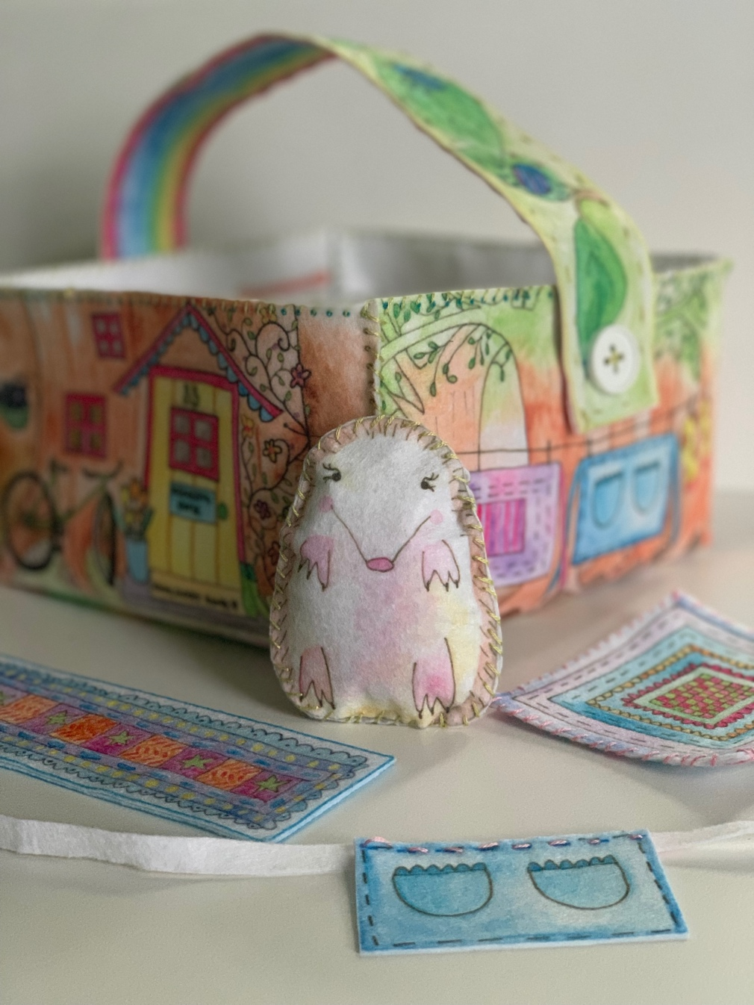

INSTRUCTOR PREPARATION

- CUT:  BLANKET BACK (This is practice piece)  - THREAD and KNOT one needle per student | 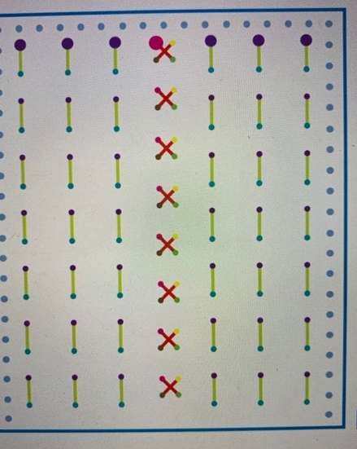
REMINDERS & DEMONSTRATIONS

Refer To “First Class” in The Sew Happy Instructor Training (Can Be Found In Instructor Binder)

WEEK 1
WEEK 1 SEWING STEPS

1. | Introduction & Demo | SEE SEPARATE NOTES  FOR WEEK 1
2. | The Practice Piece today is:  - Blanket Back
3. | Starting at one of the LARGE PURPLE DOTS close to the edge of the fabric, insert needle in the back of the fabric and pull the needle all the way through.  Insert needle in small blue dot and pull until the thread is all the way through. Repeat this “STAB STITCH” method and sew along the GREEN STITCH LINES until you get to the end of the first row of stitches.  With your needle at the back of the BLANKET, make a LOCK STITCH (by leaving a small loop and pulling needle through the loop).  Cut thread close to LOCK STITCH.  Students should now take a new piece of floss and try to thread their needles. Start another row of stitches beginning at one of the other LARGE PURPLE DOTS. | 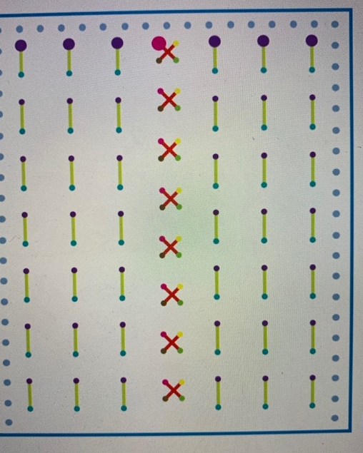
TIP! | STAB STITCH: Insert the needle in to the fabric and pull all the way through. Once a student has mastered the STAB STITCH, he/she can start to do the RUNNING STITCH where the needle is inserted in to the fabric and out again in one motion.
 | *EXTRA WORK*  Extra activities for students who finish early:  Add more stitching to BLANKET BACK. | Do NOT allow any student to move on to the next step!
WEEK 2
INSTRUCTOR PREPARATION

- CUT: STRAPS

IMPORTANT: CUT BUTTONHOLES IN BOTH STRAPS (Don’t let students do this)

- THREAD and KNOT one needle per student.
REMINDERS & DEMONSTRATIONS

- Weekly Meeting & Classroom Rules  - DEMO threading a needle using the needle threader and pincushion technique.  This week the demo and practice SHOULD TAKE 15-20 MINUTES | - Give each student a pincushion, needle and needle threader and have them practice threading the needle and tying a knot around the needle.  - REMIND students about LOCK STITCH

WEEK 2 SEWING STEPS

1. | Reminders & Demo  DO NOT SKIP THIS STEP! |  | (See Previous Page)
2. | Hand each student:  - 2 Straps:  One with stripes  One with bugs  - Pre-threaded needle if they didn’t thread their own
3. | - With WRONG SIDES together, and edges matching, PIN the straps with 2 pins.  - Starting at any corner and using a straight stitch, sew all the way around the strap following the stitch lines. |  | 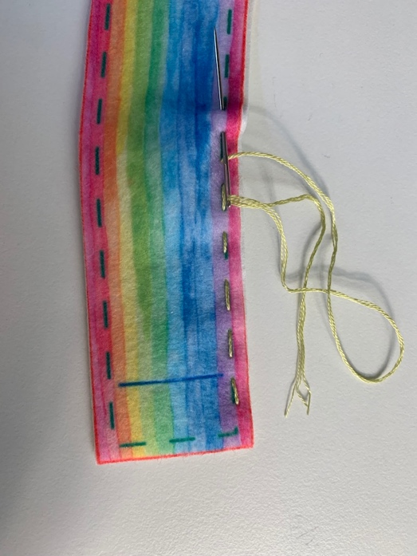
TIP! |  | As a student finishes their thread they can try to thread their own needle using the pincushion and needle threader technique.
 |  | *EXTRA WORK*  Extra activities for students who finish early:  Work on CROSS STITCHES on practice piece(BLANKET BACK). | Do NOT allow any student to move on to the next step!

INSTRUCTOR PREPARATION

- CUT:  - INSIDE BASKET  - BLANKET FRONT  - THREAD and KNOT one needle per student. | 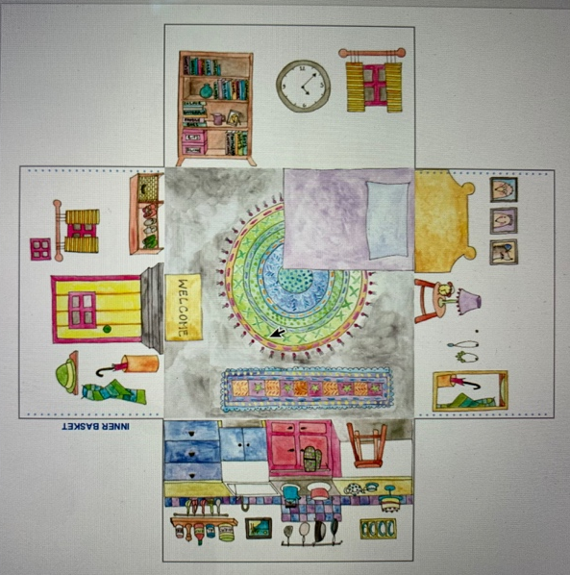
REMINDERS & DEMONSTRATIONS

- Weekly Meeting & Classroom Rules  - DEMO threading a needle using the needle threader and pincushion technique.  This week the demo and practice SHOULD TAKE 15 MINUTES | - PRACTICE - Give each student a pincushion, needle and needle threader and have them practice threading the needle and tying a knot around the needle.  - REMIND students about LOCK STITCH

WEEKS 3 & 4

WEEKS 3 & 4 SEWING STEPS

1. | Reminders & Demo  DO NOT SKIP THIS STEP! | (See Previous Page)
2. | Hand each student:  - Basket INSIDE
3. | - Match any 2 edges of the basket together.  - PIN along edge (2 Pins).  - Starting at top of basket and following the dotted stitch marks, stitch the 2 edges together using a WHIP STITCH, making sure to insert the needle in each DOT.  - WHIP STITCH – with dots facing up, insert needle through back of fabric so it comes up through a dot4. Pull thread all the way through. Repeat moving to the next DOT each time.  - Repeat for other edges of basket | 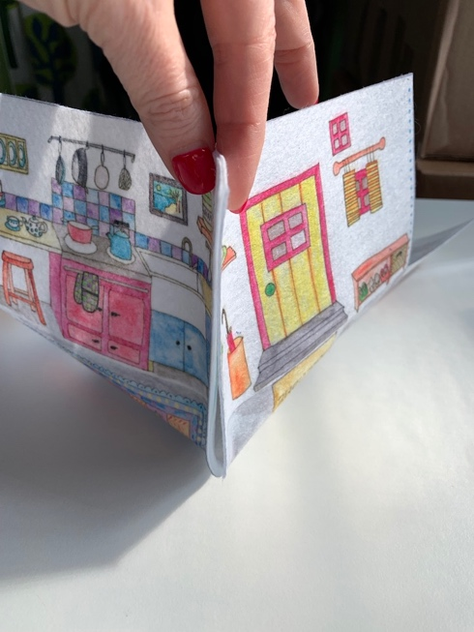  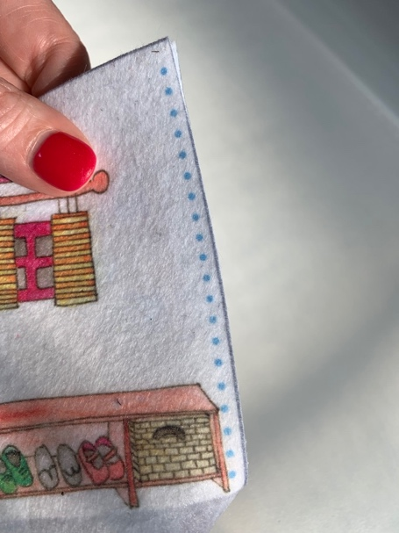  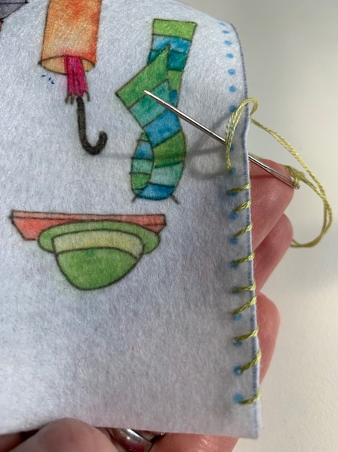
TIP! | As a student finishes their thread they can try to thread their own needle using the pincushion and needle threader technique.
 | *EXTRA WORK*  Extra activities for students who finish early:  During Week 3 there shouldn’t be any student who has completed all 4 sides.  Week 4: Start embellishing BLANKET FRONT (Students can get creative and make their own designs).  Do NOT allow any student to move on to the next step! | 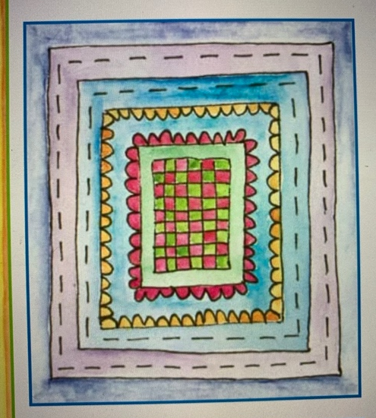

WEEK 5
INSTRUCTOR PREPARATION

- CHECK:  In each student’s bag and catch up anyone who can’t move forward to next week’s steps  - CUT:  - POCKET  - BASKET OUTSIDE  - BOOKMARK (You don’t need to cut out the front and back, just cut around both and the student can cut each one).  - THREAD and KNOT one needle per student. | 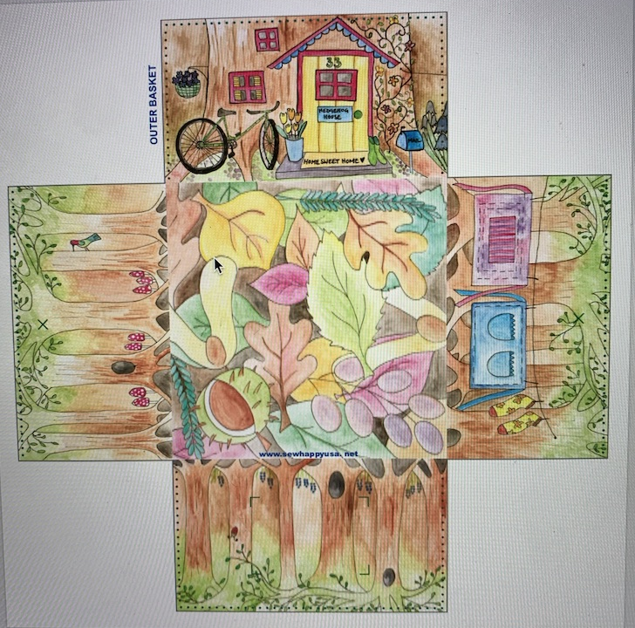  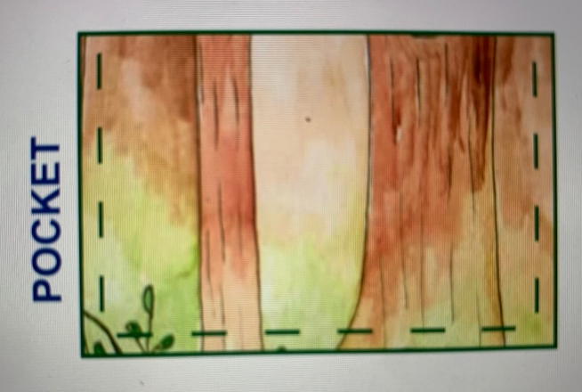

REMINDERS & DEMONSTRATIONS

- Welcome Meeting & Classroom Rules  - REFRESHER - threading a needle using the needle threader and pincushion technique.  - REFRESHER - TYING A KNOT and LOCK STITCH  This week the demo and practice SHOULD TAKE 10 MINUTES | - Practice - Give each student a pincushion, needle and needle threader and have them practice threading the needle, tying a knot around the needle and tying a knot at the end of their thread.

WEEK 5 SEWING STEPS
1. | Reminders & Demo  DO NOT SKIP THIS STEP!
2. | Hand each student:  - BASKET OUTSIDE  - POCKET
3. | - Match up the pocket to the pattern on basket.  - PIN in place.  - STITCH around 3 sides leaving the top open.  TIP – Remind students to stop when their floss gets to 4” long (use laminated rulers in instructor bin). They need to stop and make a LOCK STITCH | 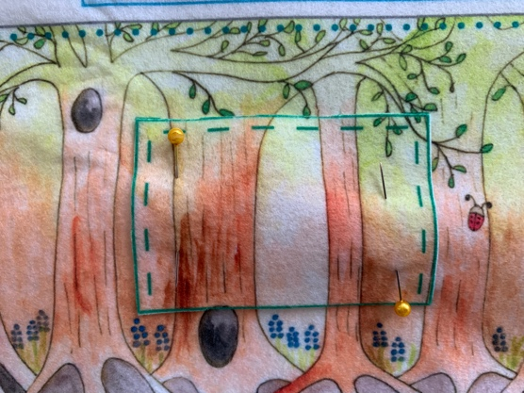
*EXTRA WORK*

Extra activities for students who finish early:
- BOOKMARK:
- Hand the piece of fabric (as in the photo) to the student.
- Student should cut BOOKMARK FRONT & BACK. If they make a mistake that’s ok, if it’s a big mistake they can use a fabric BANDAID to fix it (these are printed on the fabric).
- Embellish Bookmark Front (students have free choice here so can have fun decorating the bookmark with any stitches they choose).

Do NOT allow any student to move on to the next step!

INSTRUCTOR PREPARATION

- CUT:

- CHECK:
In each student’s bag and catch up anyone who can’t move forward to next week’s steps

- THREAD and KNOT one needle per student.

REMINDERS & DEMONSTRATIONS

- Welcome Meeting & Classroom Rules  - REFRESHER - threading a needle using the needle threader and pincushion technique.  - REFRESHER - TYING A KNOT and LOCK STITCH  This week the demo and practice SHOULD TAKE 10 MINUTES | - Practice - Give each student a pincushion, needle and needle threader and have them practice threading the needle, tying a knot around the needle and tying a knot at the end of their thread.
WEEK 6

1. | Reminders & Demo  DO NOT SKIP THIS STEP!
2. | Hand each student:  - Outside Basket  - 2 Buttons
3. | - Locate the 2 X’s on the sides of the OUTSIDE BASKET.  - Stitch buttons on (this is where strap will attach). | 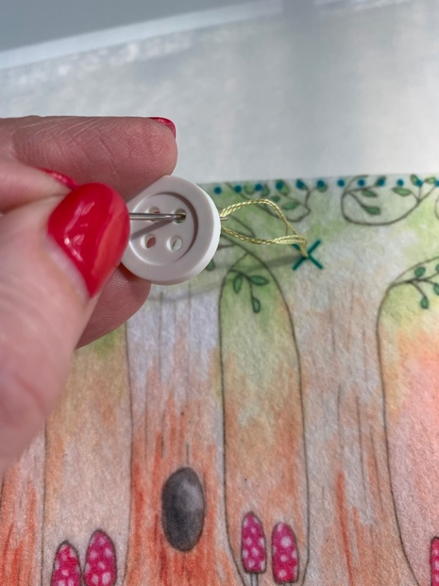
4. | - Use the same instructions as the INSIDE BASKET to sew the edges of the OUTSIDE BASKET together  - (We will continue with this step next week)
 | *EXTRA WORK*  No student should finish all 4 sides at this class. | Do NOT allow any student to move on to the next step!

WEEK 7

INSTRUCTOR PREPARATION

- CHECK:
In each student’s bag and catch up anyone who can’t move forward to next week’s steps.

- THREAD and KNOT one needle per student.

REMINDERS & DEMONSTRATIONS

- Welcome Meeting & Classroom Rules  - DEMO threading a needle using the needle threader and pincushion technique.  - DEMO TYING A KNOT and LOCK STITCH  This week the demo and practice SHOULD TAKE 5 MINUTES | - PRACTICE - Give each student a pincushion, needle and needle threader and have them practice threading the needle, tying a knot around the needle and tying a knot at the end of their thread.  - REMIND students about LOCK STITCH and KNOT.

WEEK 7 SEWING STEPS
1. | Reminders & Demo  DO NOT SKIP THIS STEP!
2. | Hand each student:  Basket OUTSIDE
3. | Continue with OUTSIDE BASKET sides (started last week)
 | *EXTRA WORK  - If a student finishes early and has completed everything, continue working on BOOKMARK | DO NOT LET A STUDENT MOVE ON TO THE NEXT STEP!

WEEKS 8 & 9

INSTRUCTOR PREPARATION

- CHECK:
In each student’s bag and catch up anyone who can’t move forward to next week’s steps.

- THREAD and KNOT one needle per student.

REMINDERS & DEMONSTRATIONS

- Welcome Meeting & Classroom Rules

- DEMO threading a needle using the needle threader and pincushion technique.

- REMIND students about TYING A KNOT and LOCK STITCH

This week the demo and practice SHOULD TAKE 5 MINUTES

WEEKS 8 & 9 SEWING STEPS

1. | Reminders & Demo  DO NOT SKIP THIS STEP!
2. | Hand each student:  Basket INSIDE  Basket OUTSIDE
3. | - Stitch Baskets Together  - Insert INSIDE BASKET inside OUTSIDE BASKET.  - Match edges and corners so baskets fit snugly together.  - PIN around top edges of basket (1 pin in each side)  - STITCH using a WHIP STITCH. | 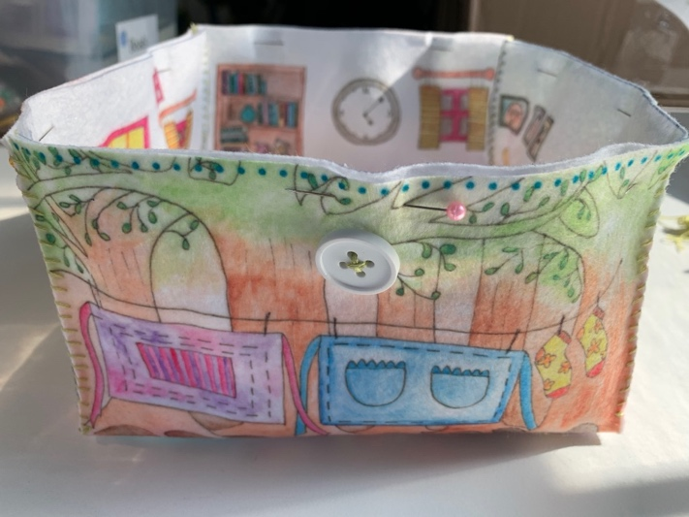
 | *EXTRA WORK  - If a student finishes early and has completed everything, work on BOOKMARK or BLANKET | DO NOT LET A STUDENT MOVE ON TO THE NEXT STEP!

WEEK 10
INSTRUCTOR PREPARATION

- CUT:  - HEDGEHOG (not keychain)  - Piece of fabric with ACCESSORIES (DO NOT CUT individual accessories)  - CHECK:  In each student’s bag and catch up anyone who can’t move forward to next week’s steps.  - THREAD and KNOT one needle per student. | 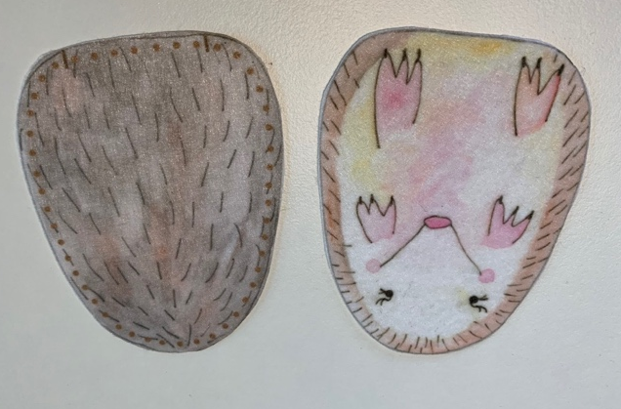
REMINDERS & DEMONSTRATIONS

- Welcome Meeting & Classroom Rules  - DEMO threading a needle using the needle threader and pincushion technique.  - DEMO TYING A KNOT and LOCK STITCH  This week the demo and practice SHOULD TAKE 5 MINUTES | - PRACTICE - Give each student a pincushion, needle and needle threader and have them practice threading the needle, tying a knot around the needle and tying a knot at the end of their thread.  - REMIND students about LOCK STITCH and KNOT.

1. | Reminders & Demo  DO NOT SKIP THIS STEP!
2. | Hand each student:  - HEDGEHOG  - Fabric with HEDGEHOG ACCESSORIES (students can cut themselves)
3. | - Match FRONT and BACK of HEDGEHOG.  - PIN  - Starting at small black mark on bottom edge of HEDGEHOG, STITCH all the way around until the second black mark.  - STUFF  - Stitch opening closed. | 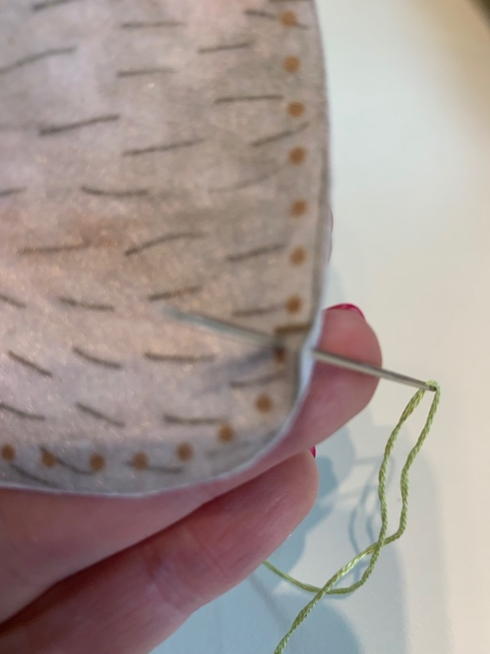
TIP!
Students will need to use a STAB STITCH (one stitch down, one stitch up) as the decorative pieces are so small.
 | *EXTRA WORK*  Extra activities for students who finish early:  - Hand students the piece of fabric with the aprons.  - Let them cut out and stitch apron ties. | Do NOT allow any student to move on to the next step!
WEEK 11
INSTRUCTOR PREPARATION

- CUT:  - KEYCHAIN  - Piece of fabric with HAT (DO NOT CUT individual accessories)  - CHECK:  In each student’s bag and catch up anyone who can’t move forward to next week’s steps  - THREAD and KNOT one needle per student. | 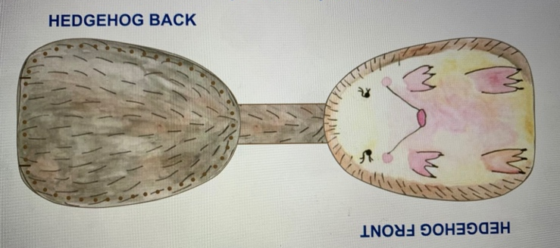
REMINDERS & DEMONSTRATIONS

- Welcome Meeting & Classroom Rules  - DEMO threading a needle using the needle threader and pincushion technique.  - DEMO TYING A KNOT and LOCK STITCH  This week the demo and practice SHOULD TAKE 5 MINUTES | - PRACTICE - Give each student a pincushion, needle and needle threader and have them practice threading the needle, tying a knot around the needle and tying a knot at the end of their thread.  - REMIND students about LOCK STITCH and KNOT.

WEEK 11 SEWING STEPS
1. | Reminders & Demo  DO NOT SKIP THIS STEP!
2. | Hand each student:  - KEYCHAIN  - KEYCHAIN RING  - Fabric with KEYCHAIN ACCESSORIES (students can cut themselves)
3. | - Slide KEYCHAIN RING over KEYCHAIN FRONT so that it is on the connecting strap  - MATCH KEYCHAIN FRONT & KEYCHAIN BACK  - PIN together  - STITCH around edges
TIP! | Students will need to use a STAB STITCH (one stitch down, one stitch up) as the decorative pieces are so small.
 | *EXTRA WORK*  Extra activities for students who finish early:  - Add more decorative stitches to both sides of keychain  - Add accessories (apron, hat) | Do NOT allow any student to move on to the next step!

WEEK 12
INSTRUCTOR PREPARATION

- CHECK:
This is the last week and a chance for everyone to catch up with any unfinished work. With that in mind look in each student’s bag and catch up anyone who looks like they won’t be able to finish today (Within Reason- if a child has missed classes you don’t need to finish all their work. In this case please make sure the student has a basket to take home, ask us if you’re not sure.)

- THREAD and KNOT one needle per student.

REMINDERS & DEMONSTRATIONS

- Welcome Meeting & Classroom Rules

- DEMO threading a needle using the needle threader and pincushion technique.

- REMIND students about TYING A KNOT and LOCK STITCH

This week the demo and practice SHOULD TAKE 5 MINUTES

WEEK 12 SEWING STEPS

1. | Reminders & Demo  DO NOT SKIP THIS STEP!
2. | Hand each student:  - ANY UNCOMPLETED WORK
3. | - FINISH uncompleted work. | 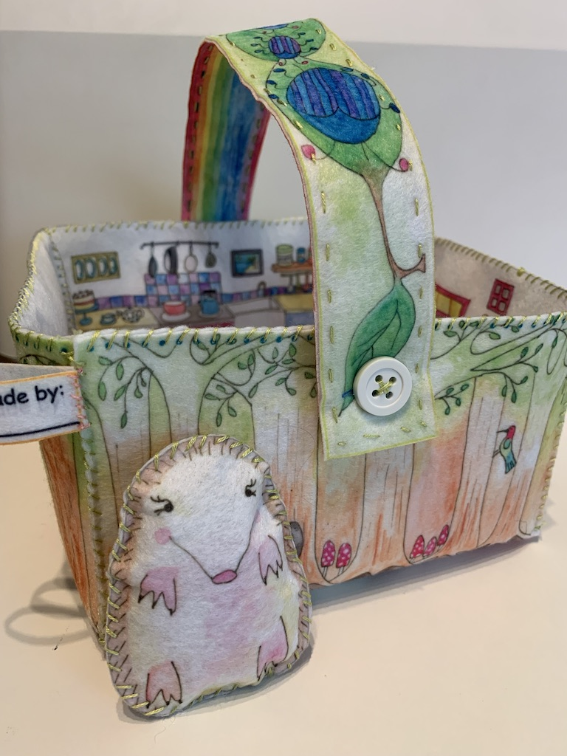
 | THE PROJECT IS COMPLETE | WELL DONE!

