Beginner Sewing Machine & Hand Sewing Combo
Lessons 6 and 7

 | Today’s Sewing Machine Project | Tic-tac-toe Travel Game (may be a different design)  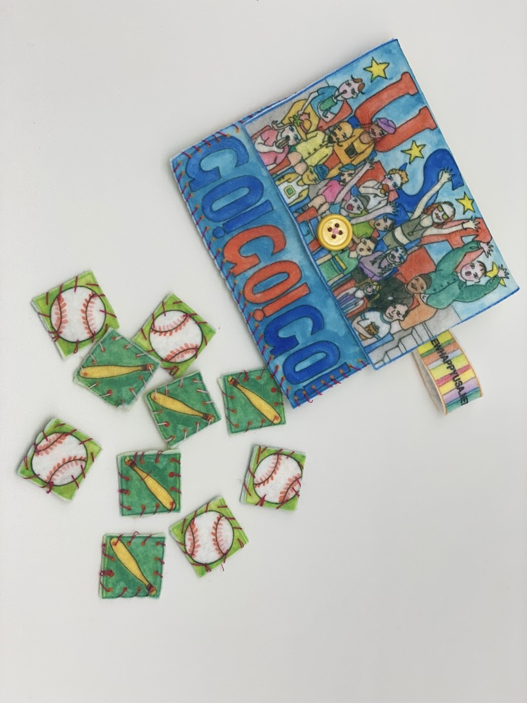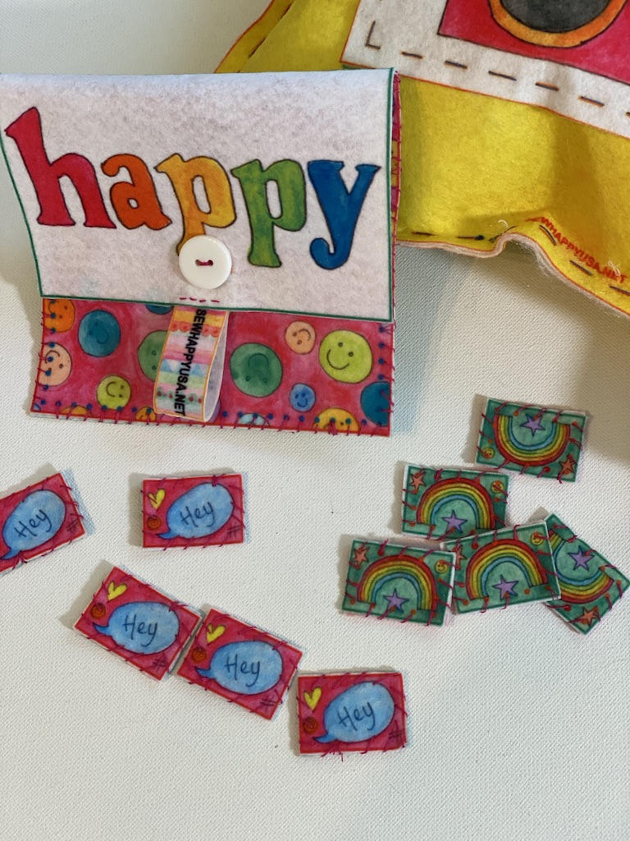
 | Today’s Hand Sewing Project | - Keychain  - Tic-tac-toe Counters
 | Today’s New Skills | Practice threading machine and inserting bobbin
 | Extra Materials Needed | - Tic-tac-toe Travel Game
10 mins | Start of Class | - Sew Happy Way (See Instructor Binder)  - Goals For Today “To make a tic-tac-toe game using the sewing machine and to hand sew the counters.”
5 Mins | Refresher | Basic Anatomy of Sewing Machine:  - On/Off Switch  - Bobbin  - Thread  - Needle  - Presser Foot  - Hand/Fly Wheel  - Presser Foot Level

15 Mins | Refresher | Threading the machine, winding and inserting a bobbin:  - Have the students practice
20 Mins | Machine Sewing | - Sew The Pouch Front To Pouch Back:  - Cut the pouch front and back  - Stitch button in place before sewing together  - Pin pouch front to pouch back (lining up edges)  - Machine stitch in place following the dotted lines, making sure to do 3 back stitches at the beginning and end  - Add “made-by” label
30 Mins | Hand Sewing | - Finish keychain  - Make counters:  - Carefully cut out all the counters  - Using one of each design, match up the counters and pin to hold together  - Using a whipstitch, sew all around each counter following the dotted stitch line.  - PLAY TIC-TAC-TOE!
10 Mins | End Of Class | Clean-up & Dismissal

