Beginner Sewing Machine & Hand Sewing Combo
Lesson 2

 | Today’s Sewing Machine Project | Introductory Felt Pouch  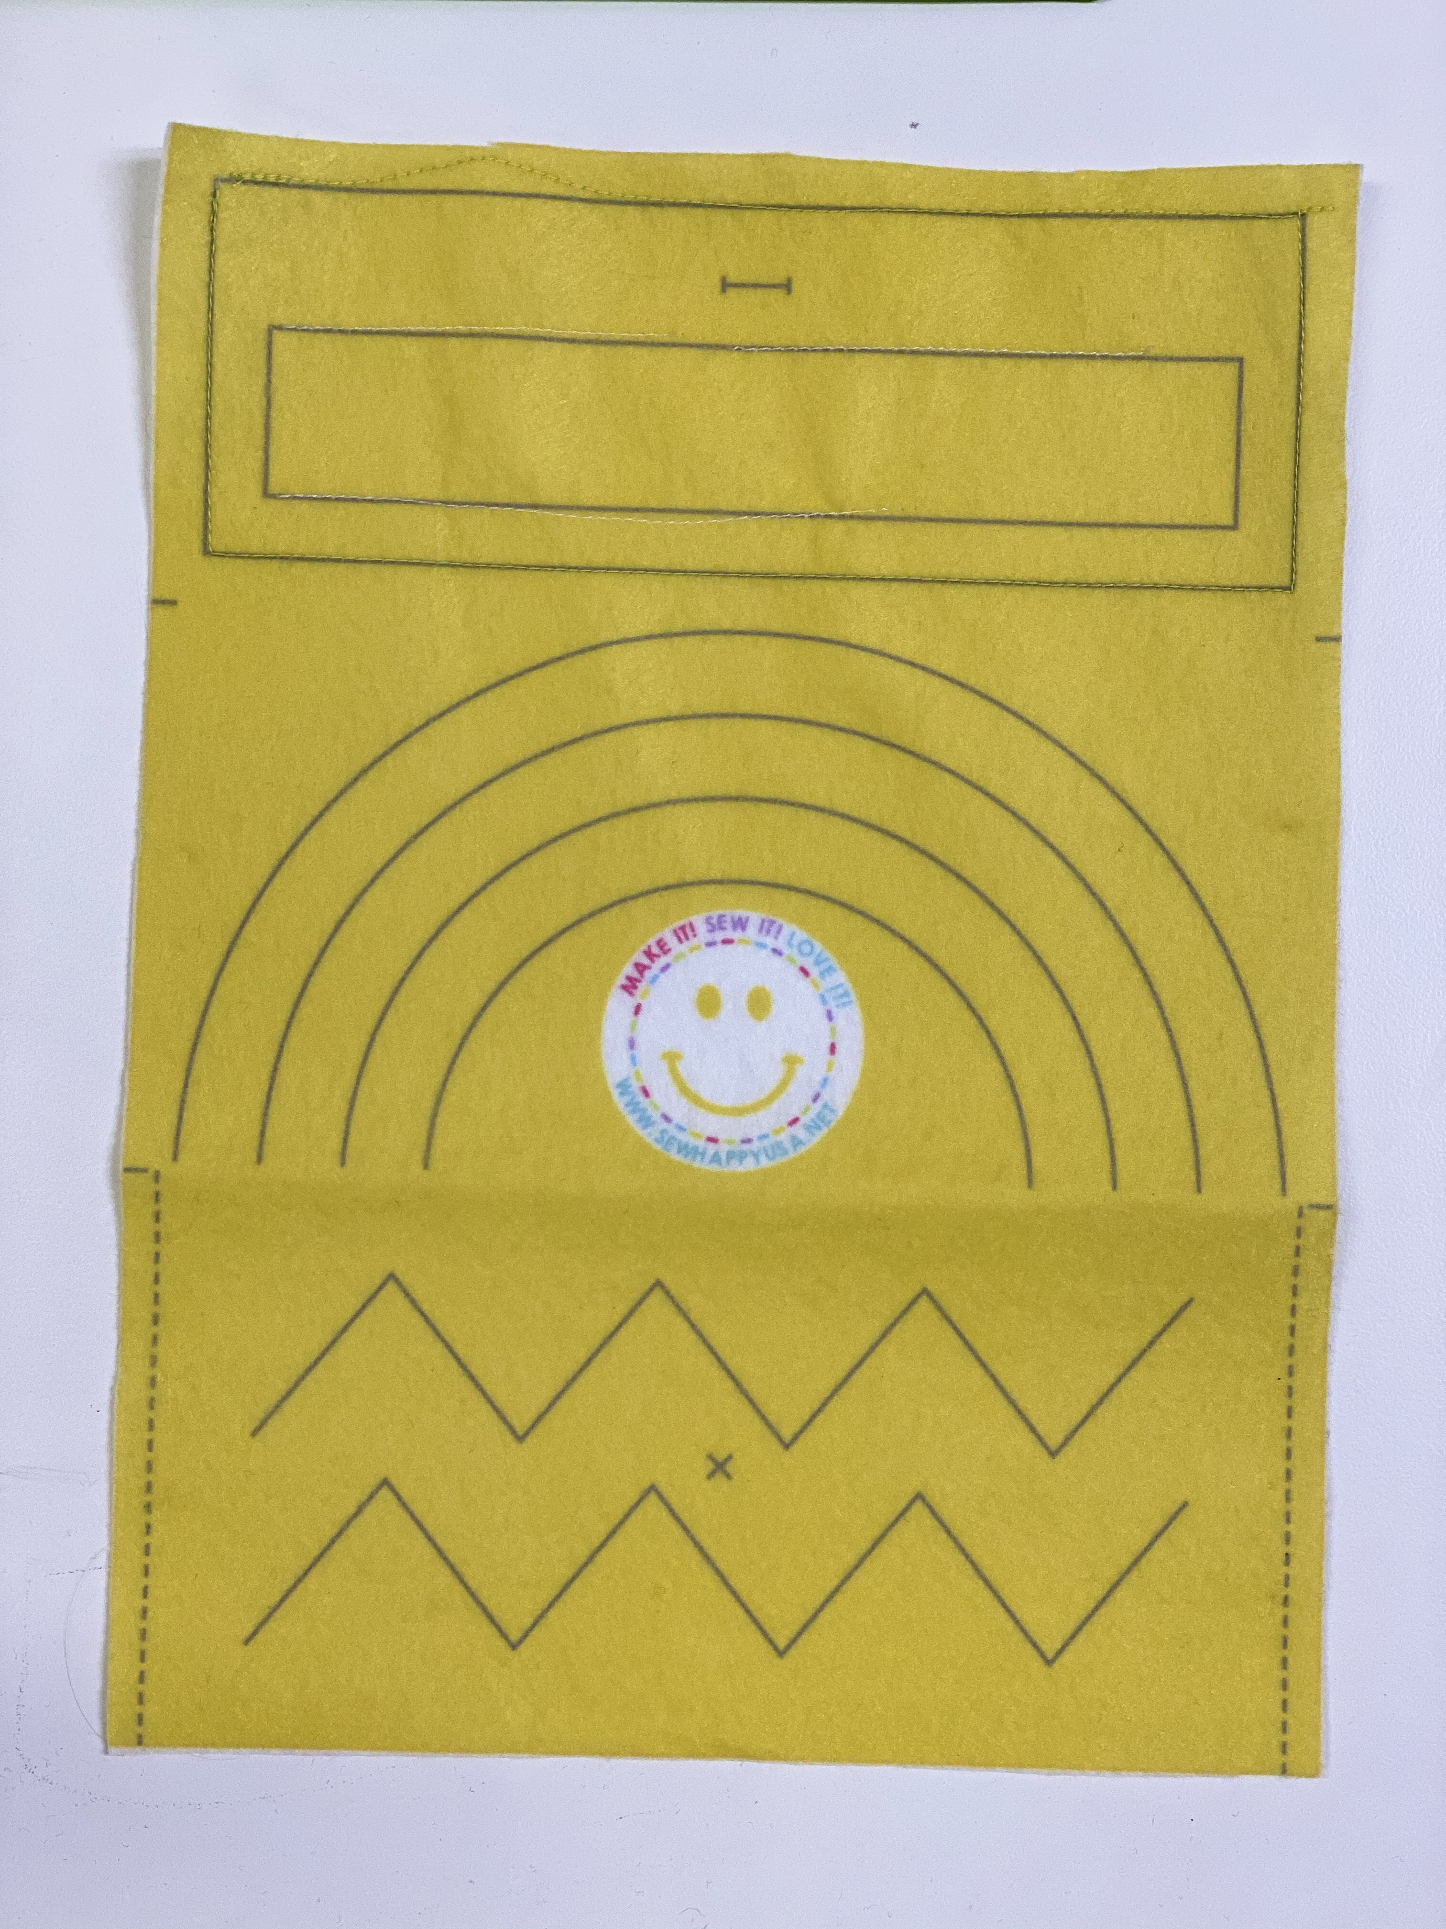
 | Today’s Hand Sewing Project | Bookmark:  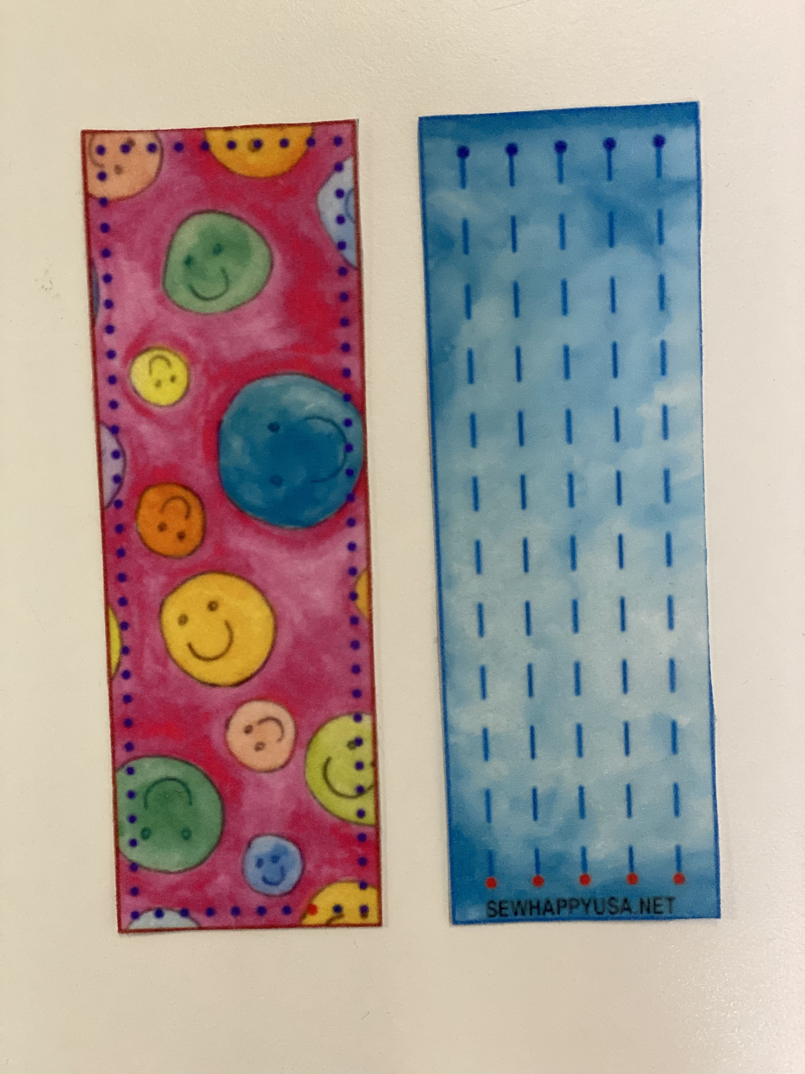
 | Note To Instructor | Pre-thread machines before class starts
 | Extra Materials Needed | - 1 Button
10 mins | Start of Class | - Sew Happy Way (see Instructor Binder)  - Goals For Today “To complete the Introductory Felt Pouch and to learn how to sew on a button”.
5 Mins | Refresher | Basic Anatomy of Sewing Machine  - On/Off Switch  - Bobbin  - Thread  - Needle  - Presser Foot  - Hand/Fly Wheel  - Presser Foot Lever  - Foot Pedal
30 Mins | Machine Sewing | Continue to sew felt pouch:  With speed on SLOWEST setting, stitch:  - Pivots/Corners (Explain how to lift presser foot and swivel while the needle STAYS in the fabric)  - Curves (Demonstrate how to lift the presser foot making small turns as you sew around the curve).  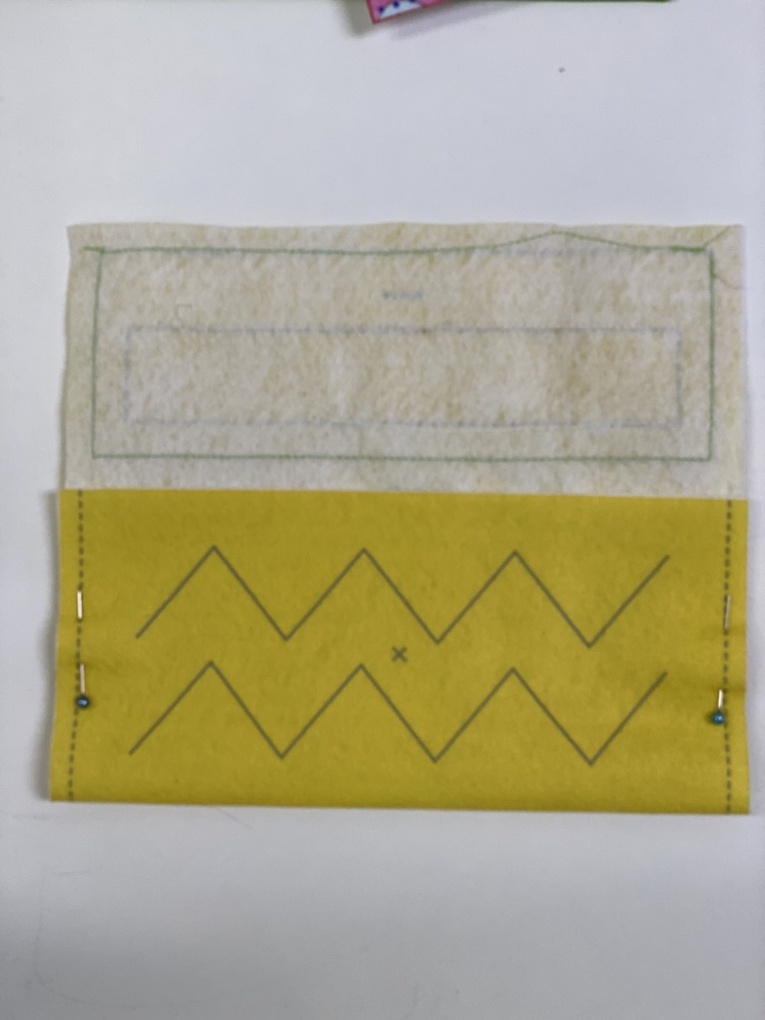  - Sew Felt Pouch Together (10 Minutes)  - Fold the felt where the small markings are and pin the pouch at both sides.  Stitch with 3 back stitches at beginning and end.
10 Mins | Demonstration/New Skill | - Sewing The Button On The Felt Pouch  Whipstitch (If there is time left over after sewing on the button)
5 Mins | Refresher | - Threading A Needle  - Tying A Knot
20 Mins | Hand Sewing | - Stitch button on to the felt pouch where the “X” is marked  - Continue working on bookmark:  - Whipstitch around edges
10 Mins | End Of Class | - Clean-up & Dismissal

