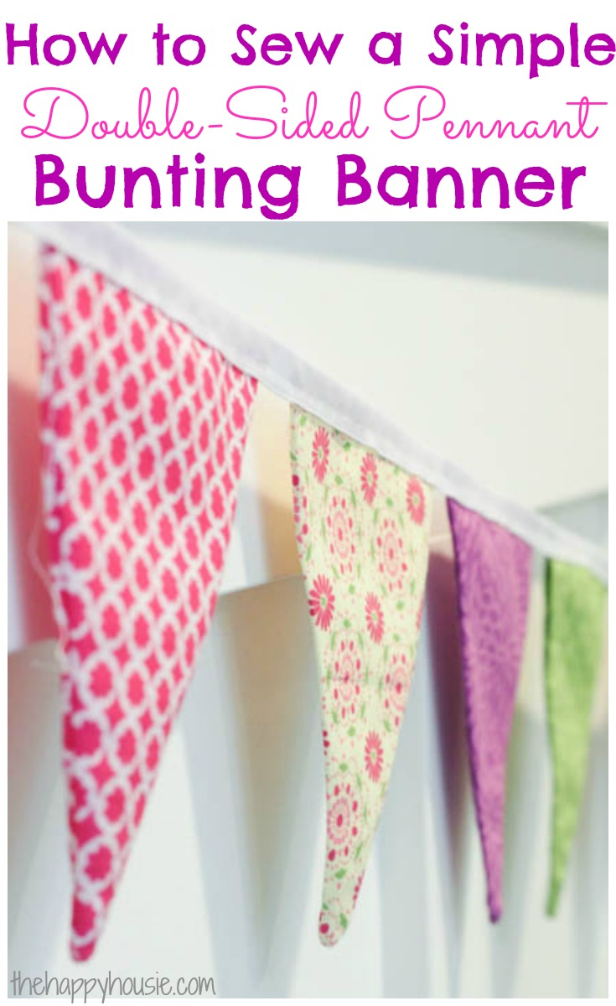
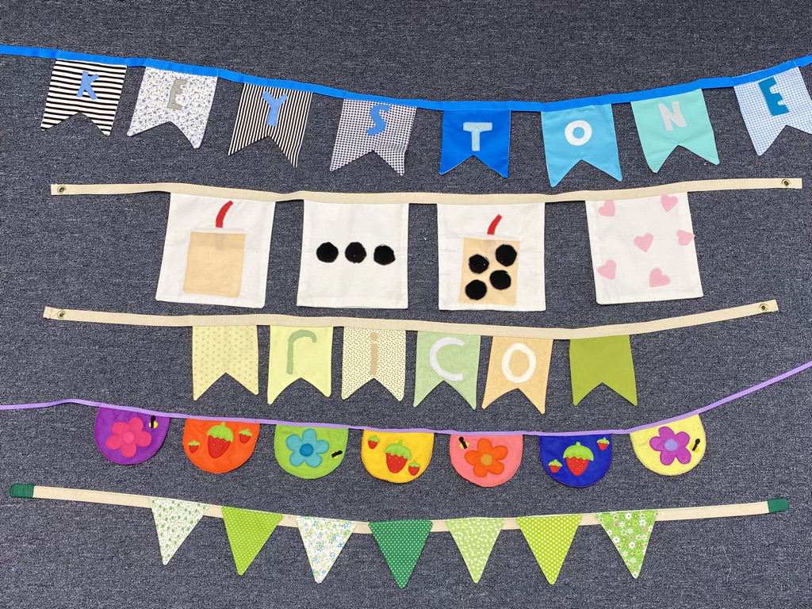

- Choose a shape (triangles, pennants, semi-circles, squares)
- Cut 8 sets of 2, remember to add a seam allowance
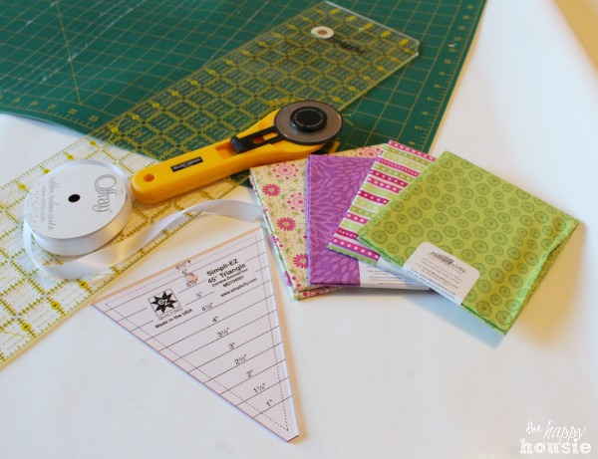
- Choose a design for the pennants and add to them before stitching the 2 sides together. Felt is easier for the designs or if you are using woven fabric use sticky backed paper (bond-a-web etc)
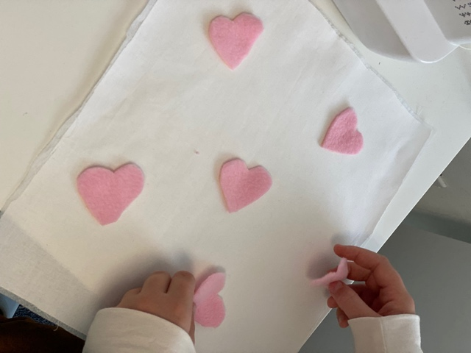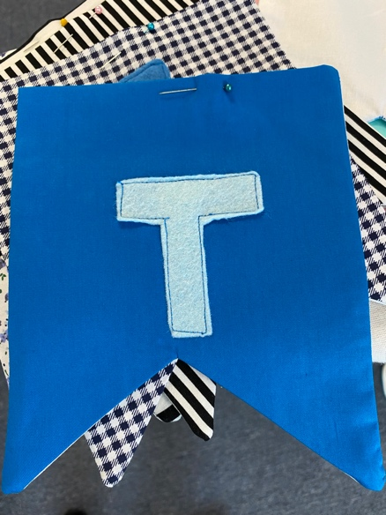
- After all the designs are done stitch each pennant together (with RST and the same seam allowance on all of them)
- Clip the points.
- Now flip the pennant inside-out so that your “right” or good sides are showing on the outside.
- Iron all the pennants flat
- Repeat with all of your pennant triangles.
- You could use a crochet hook or blunt end of a pencil to push the corners out.

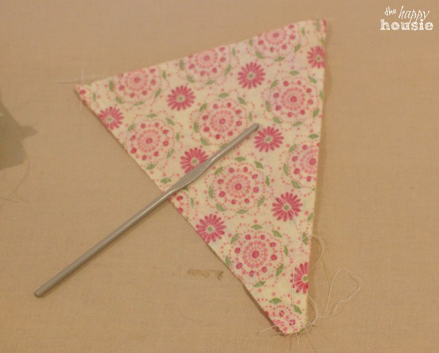
- You don’t need to stitch up the top of the triangles

- Make sure the distance between each pennant triangle is equal before pinning the ribbon or bias tape on.

- If you are using ribbon, stitch along the ribbon with a sewing machine, or if using bias tape fold it over the top of each pennant and sew.
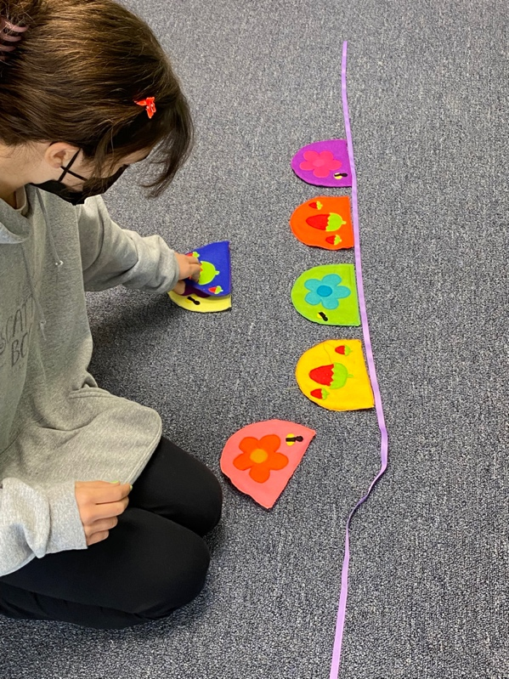
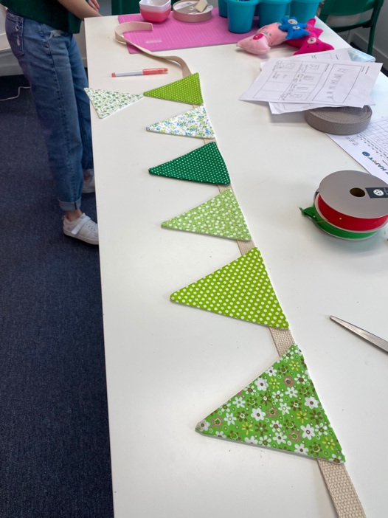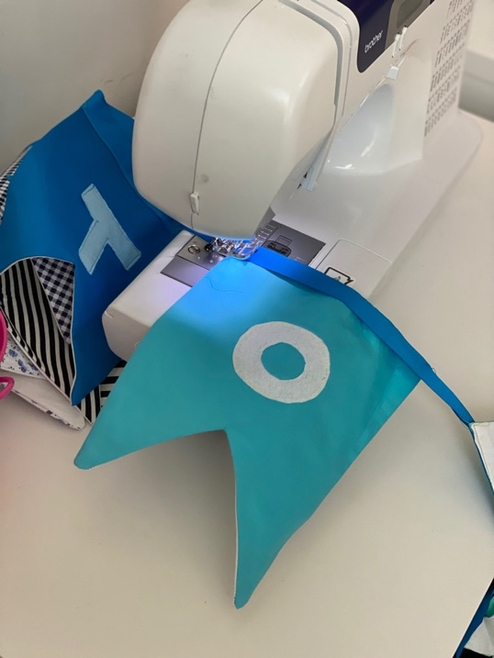
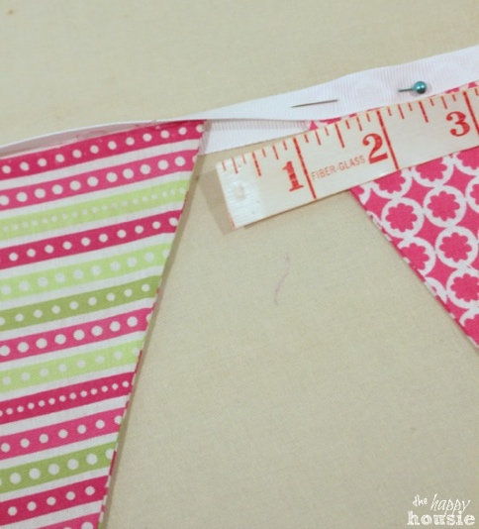
To finish off the ends stitch up along them and then use pinking shears to cut it off along the edge…Done!

