Birthday Party Pillow (Sewing Machine)

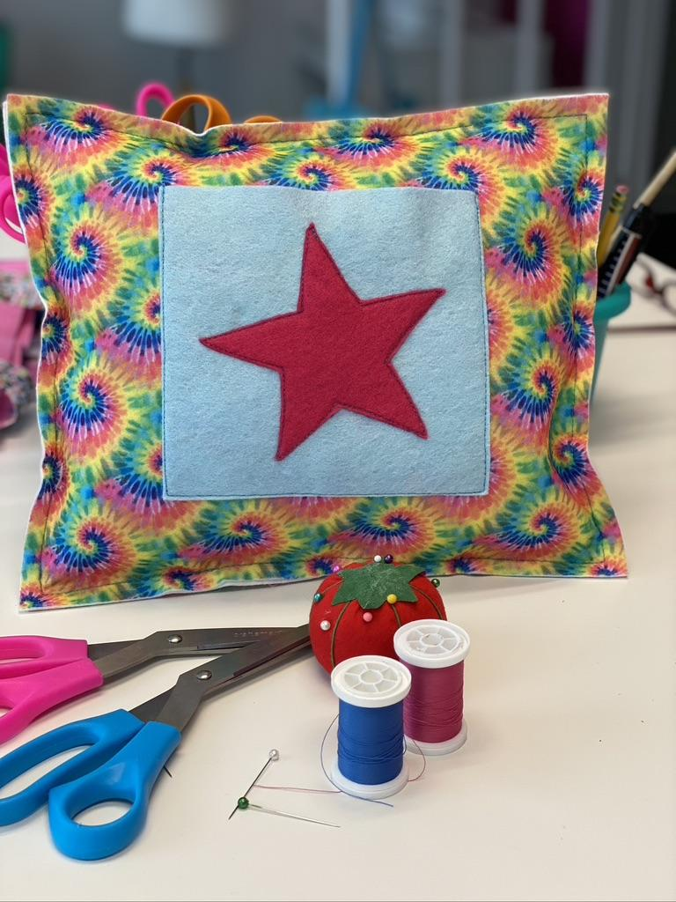

Materials:

- (2) Felt Rectangles * (approx. 12” long x 9” wide)
A selection of patterned and solid felt should be offered.

- (1) Felt Pocket Square (approx. 4”x4” or 5”x5”)

- (1) Felt Appliqué Design (i.e., Star or Heart)

- (1) Stuffing

Instructions

- Before the party:
Set-up a sewing machine for each party guest.
The machines should be threaded and ready to use when
the guests arrive.
- Use bright colored thread!
- Upper thread and bobbin thread colors don’t need to match
- Insert full bobbins only
- Set the machines to the slowest speed setting
- Test the machines to make sure they all work!

Optional – Set up the easel with “Happy Birthday name of guest” (Welcome party guests to write fun birthday messages on arrival)

- Welcome Introduction (15 Mins)
  - Introduce yourself and guests
  - Goals for today
  - Studio Rules
  - Sewing Machine Safety Briefing (Octopus board if needed.)

- Have each guest select: (5 mins)
- (2) Pillow pieces (one patterned and one solid),
- (1) Pocket Square
- (1) Appliqué Design

- Intro to sewing machine (15 mins)
  - Party guests select a bookmark
  - Following the printed stitch lines have everyone lower the needle, lower the presser foot, straight stitch, raise the needle, raise the presser foot, pull the fabric out, cut the thread
  - Repeat once or twice before starting project

- Start the pillow (10 mins)
- Arrange and pin the Appliqué to the pocket piece.
Stitch the Appliqué close to the edge.

- Arrange and pin the Pocket onto one of the Pillow pieces. (10 mins)
Stitch 3 sides of the Pocket close to the edge.
Remind them to keep the top opening unsewn.

- Sew pillow (10 mins)
  - Pin the Front and Back of the Pillow together, with WRONG sides together, the pocket opening facing upwards, and lining up all 4 edges.

  - Using a straight stitch, sew around the Pillow, 1/4” - ½” in from the edge. Demonstrate how to use the presser foot as a guide, by lining up the right side of the presser foot with the bag edge. Leave a 3” opening in the center of one edge for stuffing.

- Stuff the Pillow, using small handfuls of stuffing and making sure to push the stuffing into the corners. (10 mins)

- Stitch the opening closed (Instructors should do this part).

- If there is time left over, the party guests can:

  - use fabric markers to embellish their project
  - Complete the bookmark (with wrong sides together pin front to back and stitch around all 4 edges)

