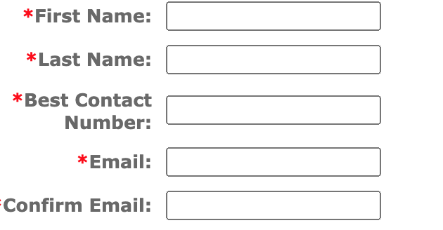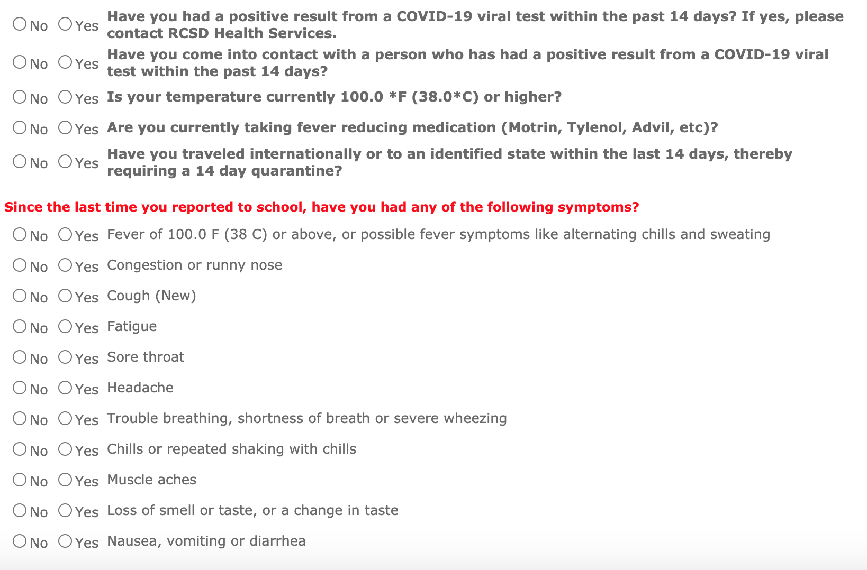

**Temperature taken by Sew Happy Instructor upon entry to Sew Happy Studio:**

I agree that the information above is true and I understand that it will be used to determine admission in to the building.

Signature of student or parent if under 18 years old:

NAME:

___________________________________________________________________________

Do you have any of the following?