Quilted Tote Bag Week 2 – Bag Design & Intro To Hand Sewing

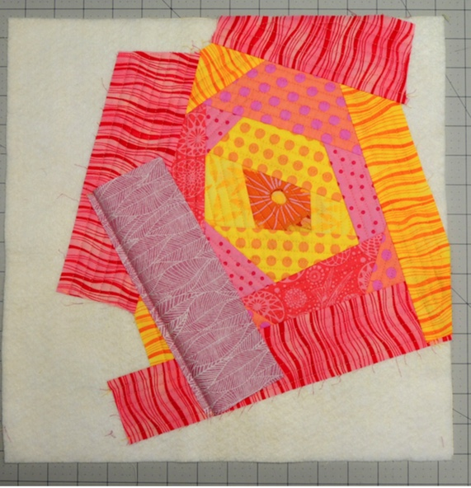

Additional Materials Required:

- Blank Paper & Pencils
- Selection of fabrics and strapping

Design Bag

- Sketch a design for the EZ Strips & QAYG, choose a color for the straps

Introduction To Hand Sewing (Bookmark may be completed over the entire session)

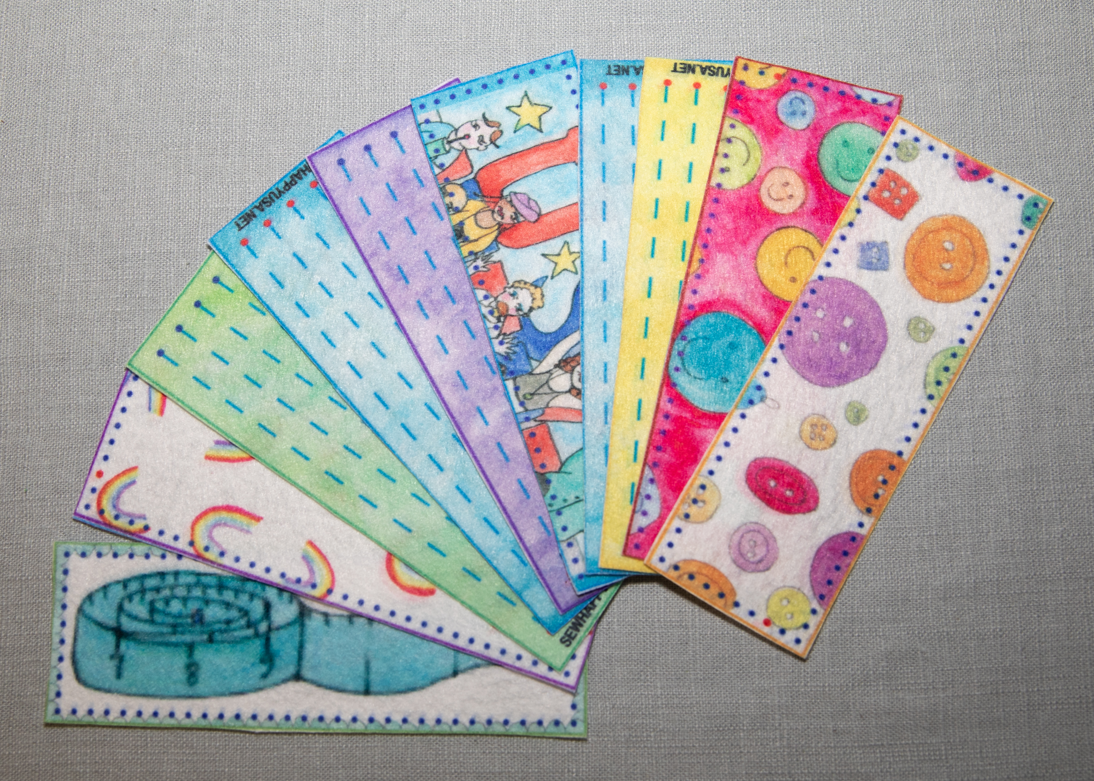

Project: Bookmark or ask Kim for another project if student has already made one at a previous class

- Demonstrate threading a needle and tying a knot
- Students practice threading a needle and tying a knot
- Demonstrate how to cut fabric
- Students cut out the bookmark, front & back
- Demonstrate straight stitch
- Students start stitching first stitch line on bookmark
- At the end of the first line demonstrate the lock stitch
- Students do a lock stitch, cut their thread and start the entire process again (thread a needle and tie a knot)
- Continue on to next stitch line
- Continue stitching straight lines on bookmark
- If a student completes all the straight lines:
  - Pin the bookmark back to bookmark front
  - Demonstrate the whipstitch
Student stitches the bookmark together using a whipstitch

