Beginner Sewing Machine & Hand Sewing Combo
Lesson 3

 | Today’s Sewing Machine Project | Pillow (may be a different design)  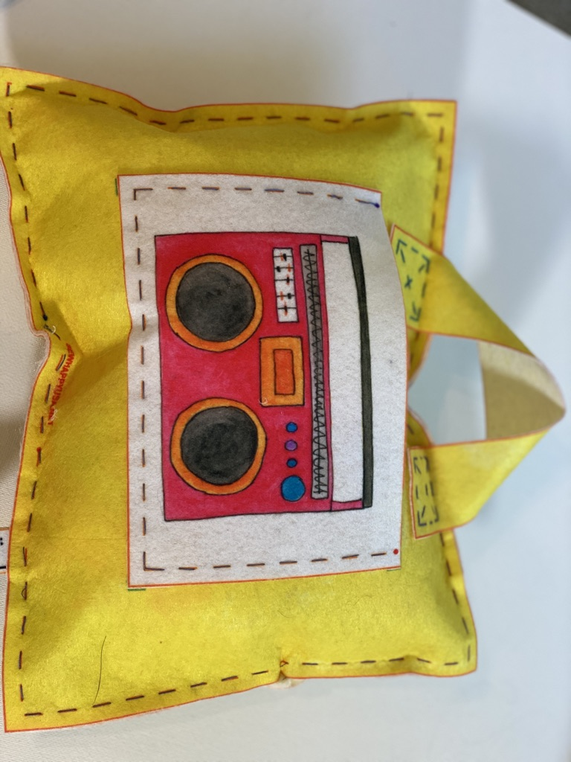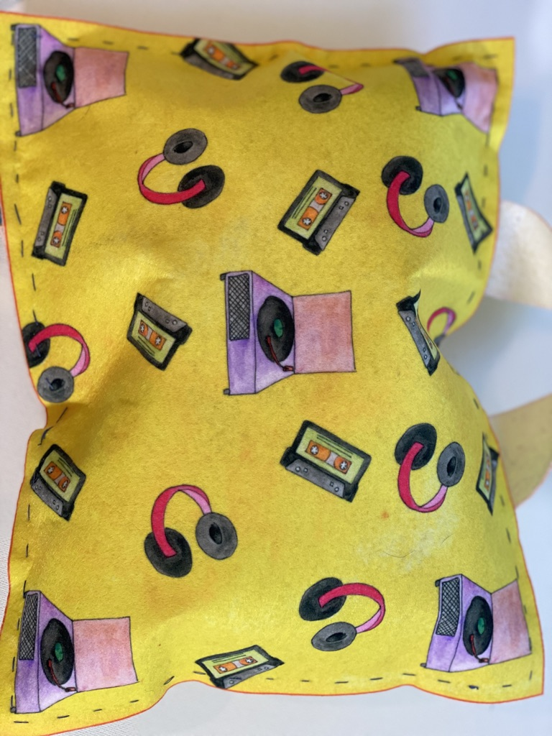
 | Today’s Hand Sewing Project | Bookmark
 | Today’s New Skills | How to thread the sewing machine (not bobbin)
 | Extra Materials Needed | - Pillow Front & Back  - 2 Pockets
10 mins | Start of Class | - Sew Happy Way (See Instructor Binder)  - Goals For Today “To choose a pocket and sew it to the pillow & to continue hand sewing the bookmark”
5 Mins | Refresher | Basic Anatomy of Sewing Machine:  - On/Off Switch  - Bobbin  - Thread  - Needle  - Presser Foot  - Hand/Fly Wheel  - Presser Foot Level

15 Mins | Demonstrations/New Skills | Demonstrate the threading of the machine:  - Have the students follow along with you (thread the needle manually, DO NOT use the needle threader).  - Have the students sew a few stitches on a scrap piece of fabric.  - Explain how they should check that the machine is threaded correctly, do the stitches look neat and flat and is the machine resisting or making any strange noises? If this is the case help them to re-thread.
20 Mins | Machine Sewing | Sew The Pocket to the Pillow Front:  - Cut pillow front and back  - Students should choose a pocket and cut it out  - Pin pocket to pillow front (lining up with markings on pillow)  - Stitch in place making sure to do 3 back stitches at the beginning and end
30 Mins | Hand Sewing | Continue working on bookmark:  - Whipstitch around edges  - Add extra decorative stitches if time allows
10 Mins | End Of Class | Clean-up & Dismissal

