Personality Pillow Week 7 - “Pocket Square”

This is one of the techniques for making a pocket. The alternative is to make a pocket like the one on the photo which has a triangle pocket flap.

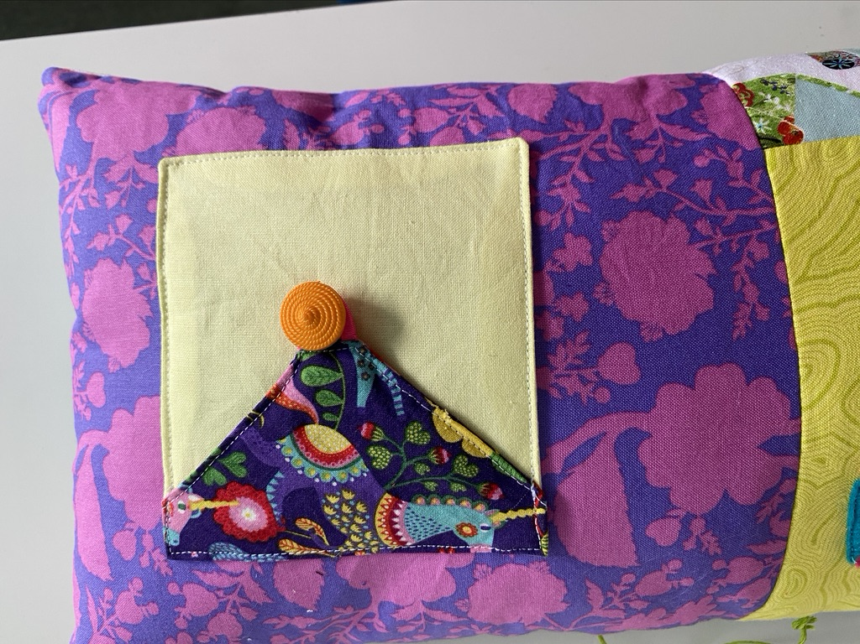

Additional Materials Required:

- 2 x (5” Fabric Squares)
- 1 x (10” x 10” Fabric)
- Button

Pocket

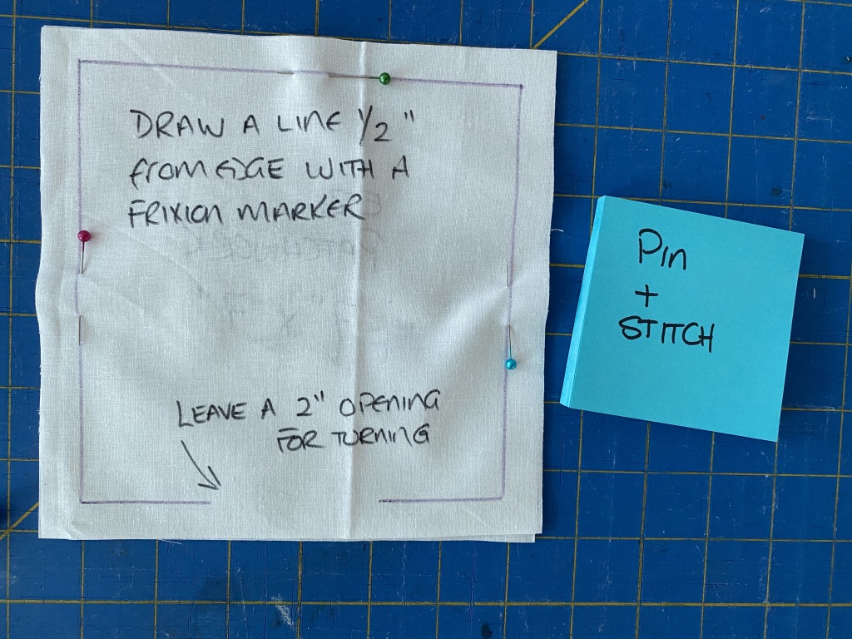
- Place the 5” squares right sides together
- Pin around edges
- Stitch around edges leaving a 2” opening in the middle of one of the sides
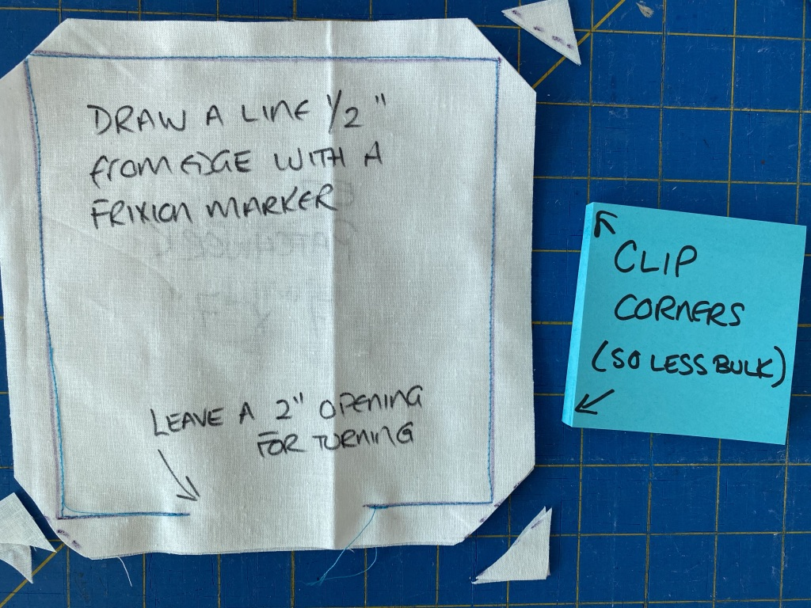

- Clip corners
- Flip to right side
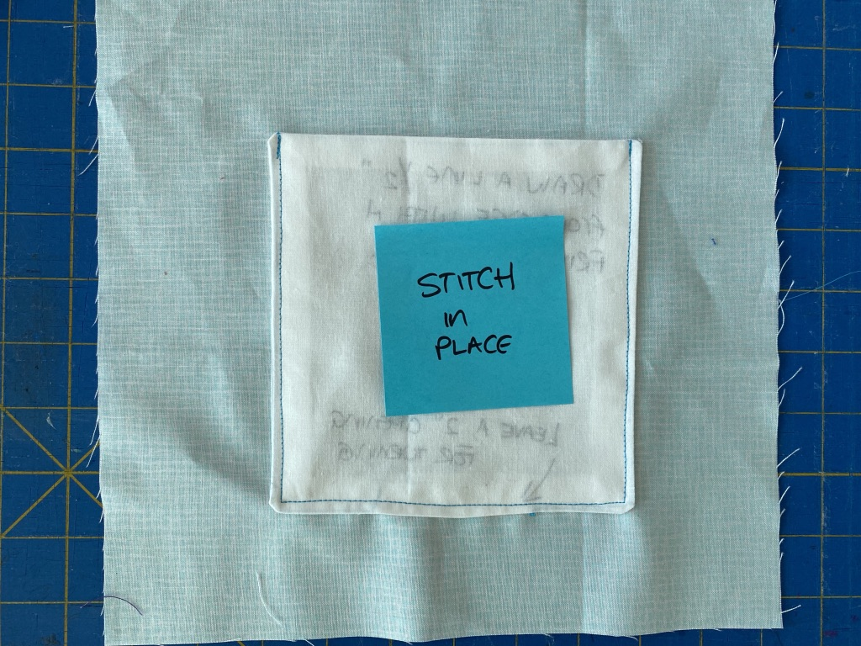

- Iron flat
- Pin on to backing square (with opening at bottom) then machine stitch around the 2 side edges and bottom edge, using a straight stitch
- If time allows add a button for decoration (no buttonhole)

