Private Lessons
Introductory Felt Pouch

Additional Materials Required:

Introductory Felt Pouch Fabric
Buttons
Hand Sewing Needles
2 or 3 Jelly Roll Strips

Instructor Set-up

- For first class set up machines, remove the covers and thread them. (Going forwards the students will do this part themselves.)

Class

- Introduction (10 Minutes)
- Introduce yourself and the other staff.
- Give a brief overview of the classes ahead showing samples of projects.
- Ask student their experience level and goals.

- Basic Anatomy of Sewing Machine (10 Minutes)
- With machines in front of students discuss the following keywords:
    - On/Off Switch
    - Bobbin
    - Thread
    - Needle
    - Presser Foot
    - Balance Wheel
    - Presser Foot Lever
    - Foot Pedal

- Safety (2-3 Minutes)
- Discuss safety hazards
- Electrical Cords - be careful not to trip
- Sharp pins & needles on floor - keep shoes on
- Keep long hair away from machine
- No food or drink around the machine

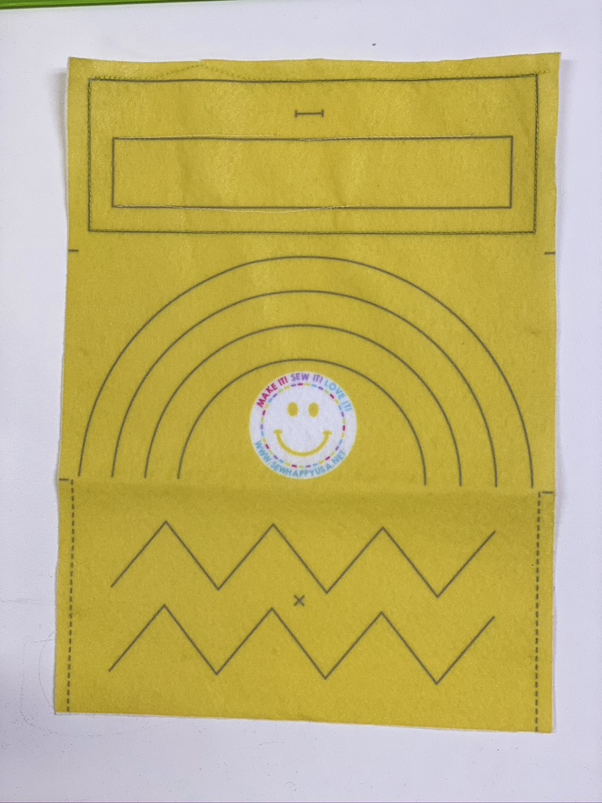

- Start To Sew Felt Pouch (Timing depends on experience of student)
With speed on a comfortable setting (most likely SLOW), start to stitch:
- Start with STRAIGHT stitch on the larger box
- Use ZIGZAG stitch on smaller box
- Pivots/Corners (Explain how to lift presser foot and swivel while the needle STAYS in the felt)
- Curves (Demonstrate how to lift the presser foot making small turns as you sew around the curve).

- Sew button on the “X”. (Demonstrate threading a needle, tying a knot and sewing on a button)

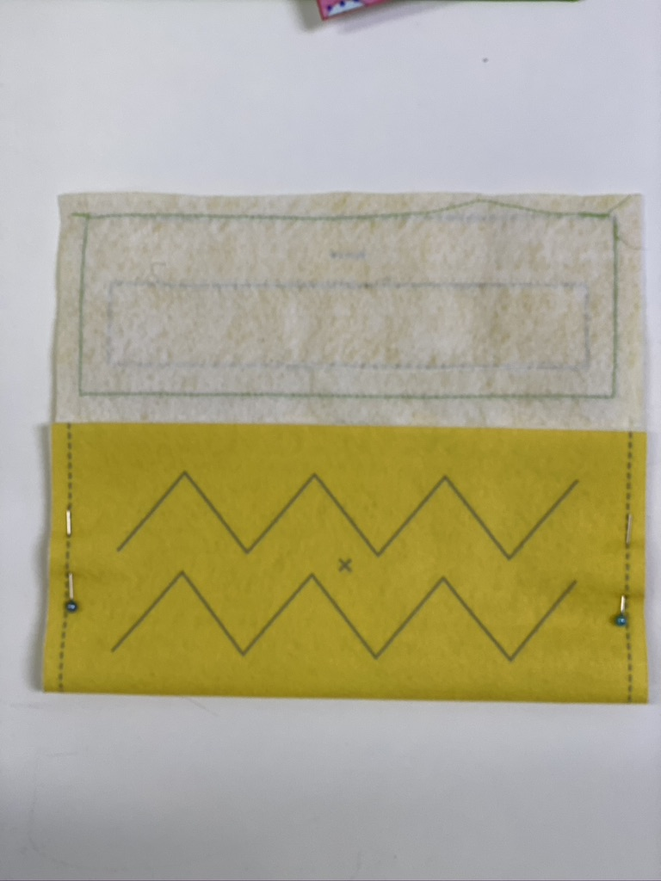

- Pin & stitch sides of pouch. (Demonstrate BACK stitch at start and end of each side)

- Cut buttonhole and the pouch is complete. There probably won’t be any time left but if the student finishes early have them start on EZ Patchwork.

- Start to sew jelly roll strips together
  - Demonstrate seam allowance, pinning, back stitch and ironing
  - Stitch 2 or 3 strips
  - Student can keep this in their bin to use towards a future EZ Patchwork project (or they can take it home if they are only taking for a single lesson)

