 | Monday | Supplies
9am – 9.15  Welcome Meeting | - Meet ‘n’ Greet  - Welcome Meeting  - Share “My name is…and I learned to sew at/when…”  Go around the room asking everyone to share where they learned to sew or if they have never sewn before what they are most looking forward to.  - Goals for the week -  - To learn how to sew  - To make a Spa Day outfit and accessories for a doll  - To make new friends  - To have a fun camp experience  - Goals for today -  - To learn how to thread a needle, tie a knot and straight stitch  - To start working on a bookmark  - Safety
9.15am - 9.40am  Welcome Activity | About Me & About My Doll  - Hand “About Me” Sheets  - Campers should spend 15 minutes completing the questionnaires  - Go around the room asking campers to tell everyone about themselves | About Me Sheet  Markers
9.40am - 10.15am  Activity 1 | - Demonstrate threading a needle and tying a knot  - Campers practice threading a needle and tying a knot  - Demonstrate how to cut fabric  - Campers cut out the bookmark, front & back | Needles (#6)  Pincushions  Needle threaders  Scissors  Floss  Bookmark

10.15am - 10.45am  Activity 2 | Stickers  - Color Stickers  - Cut stickers out | Sticker Sheets (Sweet Treats)
BREAK | CUCUMBER GAME - Campers take turns trying to stick the cucumber slices on the girls’ eyes | Pin The Cucumber Game
11am - 11.45am  Activity 3 | - Demonstrate straight stitch  - Campers start stitching first stitch line on bookmark  - At the end of the first line demonstrate the lock stitch  - Campers do a lock stitch, cut their thread and start the entire process again (thread a needle and tie a knot)  - Continue on to next stitch line  - Continue stitching straight lines on bookmark  - If a camper completes all the straight lines:  - Pin the bookmark back to bookmark front  - Demonstrate the whipstitch  - Camper stitches the bookmark together using a whipstitch
11.45am - 12pm  Clean Up / Show & Tell | - Campers should put all of their materials in their ziplock bag (Campers should write their name on a label and stick to front of bag).  - Hand each camper a wipe and ask them to wipe their work station including the hand wheel on the sewing machine and the desktop.  - Instructor - do show and tell today and tell the campers they are welcome to bring a show & tell item any day during camp  - Ask campers to share “What I liked about Day 1 at camp”  - If there is still time ask a “Would You Rather” question or two. | Ziplock Bag  Name Label  Instructor Show & Tell Item
12pm  Dismissal | - Have campers collect their belongings (water bottle, phone etc)  - Have campers line up  - Instructor should lead the group down to the pick-up location in a quiet and orderly manner  - Follow dismissal procedure  - Return to studio, sanitize and clean so it’s ready for next class

 | Tuesday
9am – 9.15  Welcome Meeting | - Meet ‘n’ Greet  - Welcome Meeting  Go around the room asking everyone to introduce their doll and share her favorite activity  - Goals for the week -  - To learn how to sew  - To make a Spa Day outfit and accessories for a doll  - To make new friends  - To have a fun camp experience  - Goals for today -  - To cut out the wrap and the petals  - To stitch the petals on the wrap  - To sew the buttons on to the wrap  - Safety
9.15am - 9.40am  Welcome Activity | About My Doll  - Hand out “About My Doll” Sheet  - Campers should spend 15 minutes completing the questionnaires  - Campers talk about their dolls  - If there is still time you can start the sewing activity early | About My Doll Sheets
9.40am - 10.15am  Activity 1 | - Campers cut out wrap (2 pieces) and flower petals  - Refresher - Demonstrate threading a needle and tying a knot  - Campers practice threading a needle and tying a knot  - Campers start pin and stitch flower petals in place on wrap  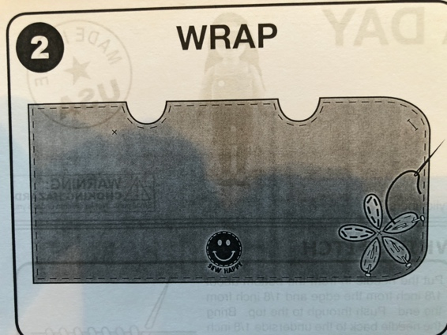  - With printed sides up, pin each petal to the wrap, centered over the placement lines. Using a running stitch, stitch each petal in place, following the printed stitching lines. | Wrap (Blue and green)  Flower Petals  Sewing Supplies
10.15am - 10.45am  Activity 2 | - Color Spa Towel with fabric markers  - Cut it out

BREAK | SPA DAY BINGO | SPA DAY BINGO SUPPLIES
11am - 11.45am  Activity 3 | 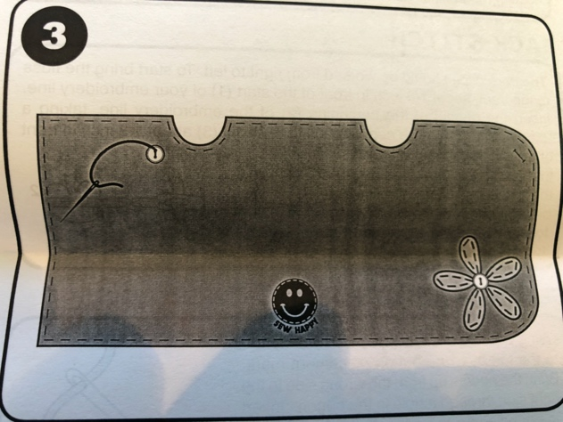  - Campers stitch the 2 buttons on the wrap  - Tape buttons to the wrap at the button placement marks. Stitch buttons in place.  - The instructor should cut buttonhole on the wrap and wrap lining.
11.45am - 12pm  Clean Up / Show & Tell | - Campers should put all of their materials in their ziplock bag.  - Hand each camper a wipe and ask them to wipe their work station including the hand wheel on the sewing machine and the desktop.  - Show & Tell - Encourage campers to share a doll story  - Ask campers to share “What I liked about Day 2 at camp”  - If there is still time ask a “Would You Rather” question or two.
12pm  Dismissal | - Have campers collect their belongings (water bottle, phone etc)  - Have campers line up  - Instructor should lead the group down to the pick-up location in a quiet and orderly manner  - Follow dismissal procedure  - Return to studio, sanitize and clean so it’s ready for next class

 | Wednesday
9am – 9.15  Welcome Meeting | - Meet ‘n’ Greet  - Welcome Meeting  Go around the room asking everyone to share an imaginative doll adventure  - Goals for the week -  - To learn how to sew  - To make a Spa Day outfit and accessories for a doll  - To make new friends  - To have a fun camp experience  - Goals for today -  - To finish the wrap and the petals  - To make the eye mask  - To make the cucumber slices  - Safety
9.15am - 9.40am  Welcome Activity | Spa Day Word Search  - Hand out Spa Day Word Search Sheet  - Campers should spend 15 minutes completing the questionnaires  - Campers can see if they got the right answers  - If there is still time you can start the sewing activity early | Word Search Sheets
9.40am - 10.15am  Activity 1 | - With edges even, pin the blue wrap to the green wrap lining. The printing should be visible on both the wrap and lining.  - Using a running stitch, stitch around the wrap, following the printed stitching lines.  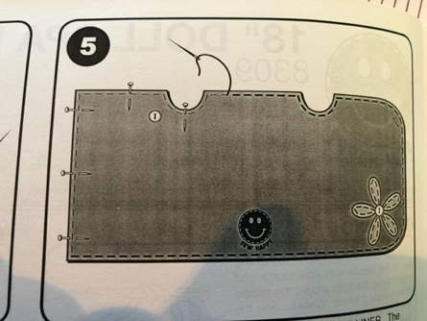
10.15am - 10.45am  Activity 2 | - Campers cut out eye mask  - Refresher - Demonstrate threading a needle and tying a knot  - Campers practice threading a needle and tying a knot  - Campers pin and stitch eye mask, inserting ribbon ties  - With printed sides up and edges even, pin the blue eye mask to the green eye mask lining.  - Stitch around the eye mask leaving the top edge unsewn. (7)  - Pin the ribbon to the blue eye mask so that the top edge of the ribbon is even with the top edge of the eye mask. (9)  - Stitch ribbon to eye mask.  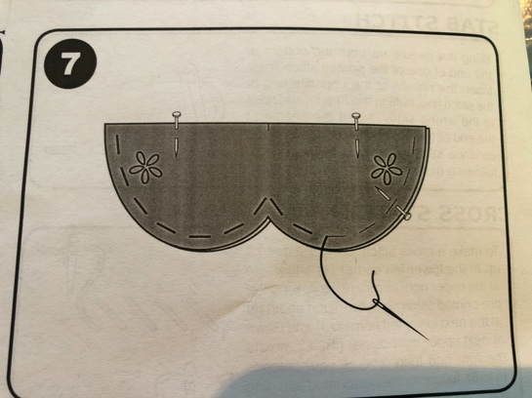  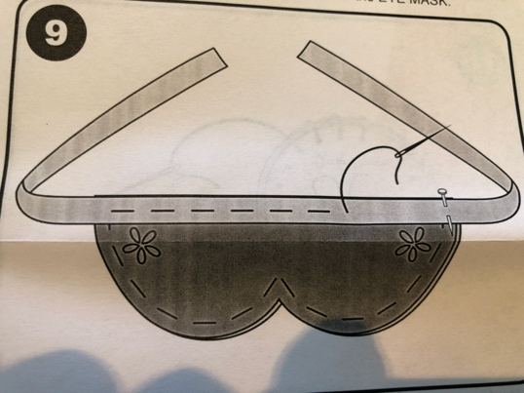 | Sewing Supplies  Eye Mask & Ribbon

BREAK | WOULD YOU RATHER…
11am - 11.45am  Activity 3 | - Cut out cucumber slices  - Pin and stitch together  - Either stitch seeds or use a fabric marker to color the seeds | Cucumber Slices  Fabric Markers
11.45am - 12pm  Clean Up / Show & Tell | - Campers should put all of their materials in their ziplock bag.  - Hand each camper a wipe and ask them to wipe their work station including the hand wheel on the sewing machine and the desktop.  - Show & Tell - campers bring or talk about their doll’s best friend  - Ask campers to share “What I liked about Day 3 at camp”  - If there is still time ask a “Would You Rather” question or two.
12pm  Dismissal | - Have campers collect their belongings (water bottle, phone etc)  - Have campers line up  - Instructor should lead the group down to the pick-up location in a quiet and orderly manner  - Follow dismissal procedure  - Return to studio, sanitize and clean so it’s ready for next class

 | Thursday
9am – 9.15  Welcome Meeting | - Meet ‘n’ Greet  - Welcome Meeting  Go around the room asking everyone to introduce their doll and share her favorite spa treatment  - Goals for the week -  - To learn how to sew  - To make a Spa Day outfit and accessories for a doll  - To make new friends  - To have a fun camp experience  - Goals for today -  - To make the spa slippers  - Safety
9.15am - 9.40am  Welcome Activity | Secret Code  - Hand out Secret Code Sheet  - Campers should spend 15 minutes completing the quiz  - Campers share their findings  - If there is still time you can start the sewing activity early | Secret Code Sheets  Markers
9.40am - 10.15am  Activity 1 | - Campers cut out slippers  - Refresher - Demonstrate threading a needle and tying a knot  - Campers practice threading a needle and tying a knot  - Campers pin and start to stitch slippers  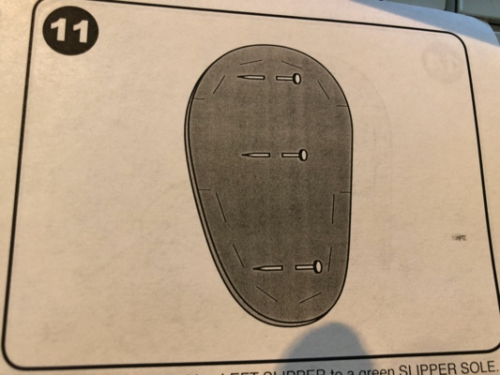  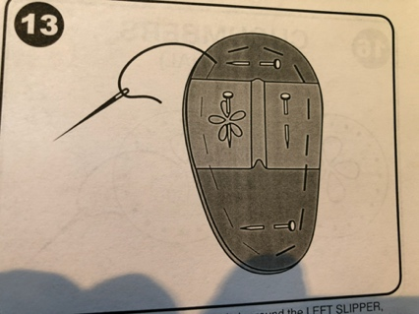  - Pin the blue and green slipper together and stitch.  - Pin the slipper top in place and stitch.  - Repeat with other slipper. | Slippers
10.15am - 10.45am  Activity 2 | Draping on 18” Mannequins  Campers use supplied fabrics and ribbons to create outfits using draping technique (no cutting or sewing)

BREAK | WOULD YOU RATHER…
11am - 11.45am  Activity 3 | - Finish slippers
11.45am - 12pm  Clean Up / Show & Tell | - Campers should put all of their materials in their ziplock bag.  - Hand each camper a wipe and ask them to wipe their work station including the hand wheel on the sewing machine and the desktop.  - Show & Tell - Campers bring or talk about their doll’s pet  - Ask campers to share “What I liked about Day 4 at camp”  - If there is still time ask a “Would You Rather” question or two.
12pm  Dismissal | - Have campers collect their belongings (water bottle, phone etc)  - Have campers line up  - Instructor should lead the group down to the pick-up location in a quiet and orderly manner  - Follow dismissal procedure  - Return to studio, sanitize and clean so it’s ready for next class

 | Friday
9am – 9.15  Welcome Meeting | - Meet ‘n’ Greet  - Welcome Meeting  Go around the room asking everyone to pitch their doll spa ideas  - Goals for the week -  - To learn how to sew  - To make a Spa Day outfit and accessories for a doll  - To make new friends  - To have a fun camp experience  - Goals for today -  - To complete the wrap, eyemask and slippers  - Safety
9.15am - 9.40am  Welcome Activity | Getting To Know A Friend  - Hand out GTKAF Sheet  - Campers should spend 15 minutes completing the questionnaires (can be about an existing friend or a camp friend)  - Campers share their findings  - If there is still time you can start the sewing activity early | GTKAF Sheets
9.40am - 10.15am  Activity 1 | - Campers complete all projects
10.15am - 10.45am  Activity 2 | - Finish all projects

BREAK | CAMPER CHOICE (PIN THE CUCUMBER, SPA DAY BINGO, WOULD YOU RATHER…)
11am - 11.45am  Activity 3 | - If all projects are complete, campers should dress up their dolls and have a fashion show
11.45am - 12pm  Clean Up / Show & Tell | - Campers should put all of their extra materials away  - Hand each camper a wipe and ask them to wipe their work station including the hand wheel on the sewing machine and the desktop.  - Show & Tell - Campers bring or talk about their favorite part of camp  - Ask campers to share “What I liked about camp”  - Tell campers which other camps are available  - If there is still time ask a “Would You Rather” question or two.
12pm  Dismissal | - Have campers collect their belongings (water bottle, phone etc)  - Have campers line up  - Instructor should lead the group down to the pick-up location in a quiet and orderly manner  - Follow dismissal procedure  - Return to studio, sanitize and clean so it’s ready for next class | Samples:  Fox In A Sleeping Bag  Ice Cream  Chill Out  Surf’s Up  All Dressed Up  Hedgehog House  Llama Drama

