Beginner Sewing Machine & Hand Sewing Combo
“Pillows & More”
Lesson 1

 | Today’s Sewing Machine Project | Introductory Felt Pouch  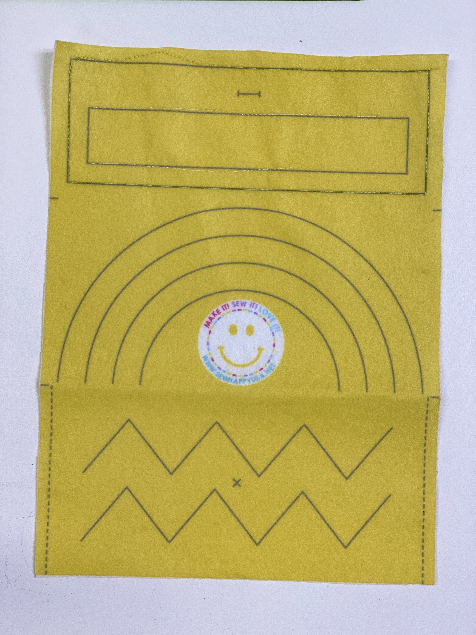
 | Today’s Hand Sewing Project | Bookmark  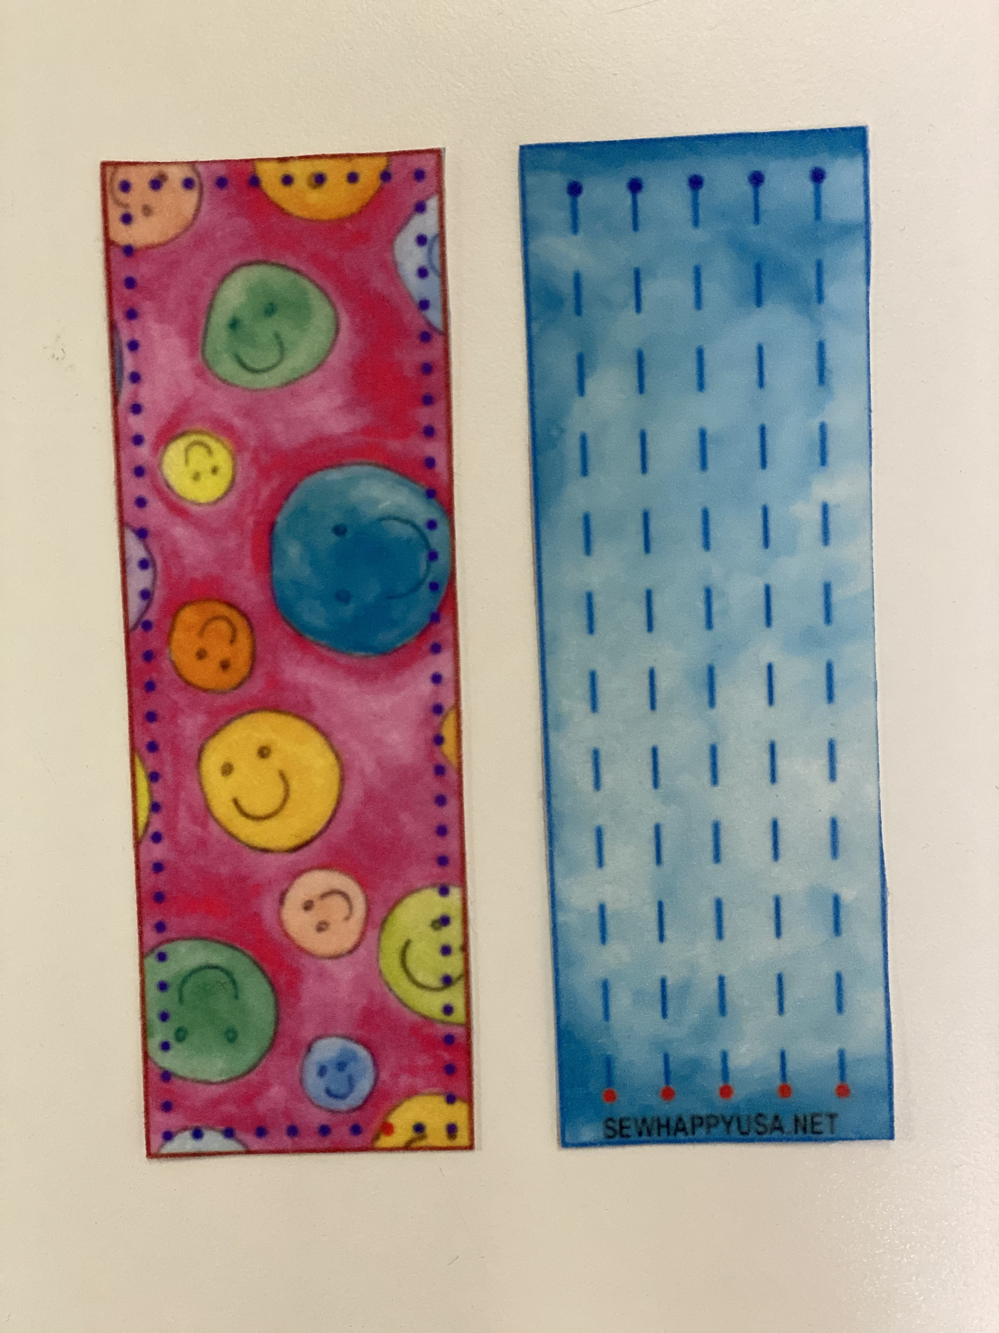
 | Note To Instructor | Pre-thread machines before class starts. Use bright colored threads that will show up on Intro Felt Pouch
 | Today’s New Skills | Students Will Learn The Basics Of Machine & Hand Sewing
 | Extra Materials Needed | - Intro Felt Pouch Fabric  - Felt Bookmark Front & Back
10 mins | Start of Class | Introduction:  - Introduce yourself and tell the kids what name to call you (Miss Kim, Mrs. M. etc.)  - Ask students to introduce themselves  - Sew Happy Way (follow notes in Instructor Binder)  - Goals For Today - “To learn the basics of machine sewing and hand sewing”
10 Mins | Anatomy Of Sewing Machine | - On/Off Switch  - Bobbin  - Thread  - Needle  - Presser Foot  - Hand/Fly Wheel  - Presser Foot Lever  - Foot Pedal

20 Mins | Machine Sewing | Start Machine Sewing using Intro Felt Pouch  With speed on SLOWEST setting:  - Line fabric up underneath the needle  - Lower needle using hand wheel (turn towards you or anti-clockwise)  - Lower presser foot  - Press foot pedal  - Start stitching the STRAIGHT LINES on the boxes  - Pivot at each corner by lifting presser foot, turning fabric and lowering presser foot again.  - Press the needle position button to raise needle when box is complete.  - If there is time complete the 2 rectangles but you will continue with this at the next lesson
 |  | STOP MACHINE SEWING
40 Mins | Hand Sewing | Using machine thread and working on the side of the bookmark with the stitch lines, demonstrate:  - How to cut fabric  - How to measure thread  - How to thread a needle  - How to tie a knot  - Straight stitch  - Lock stitch  (It’s ok if you don’t get to do all of these as you will be continuing next week)
10 Mins | End Of Class | Clean-up & Dismissal

