Personality Pillow Lesson 5 - “Initial Square”

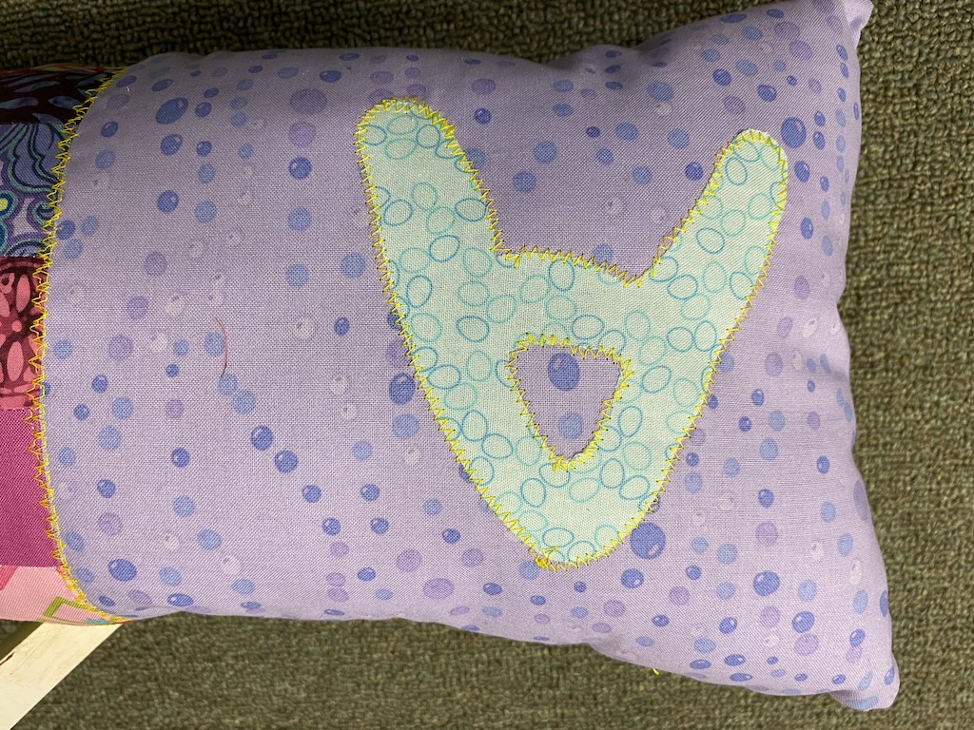

Additional Materials Required:

- Fabric Squares (2 or 3 per person - Approx 4” x 4” backed with “magic” paper)
- 10” Fabric Square

Initial Square

- Choose 1 fabric square (backed with “magic” paper) and draw initial on paper side (make sure it’s in reverse)
- Cut initial
- Peel off backing paper and place on 10” fabric square.
- Iron in place then machine stitch around edge, using either a straight stitch or zigzag stitch.
- Repeat for the design element (heart, emoji etc) KEEP IT SIMPLE!
- If time permits use hand stitches to embellish
- or FREE SEW

